On motion of Ms. Van Vrancken, seconded by Mr. Roberts, the following ordinance was offered:

**SUMMARY NO. 24796 ORDINANCE NO. 25411**

An ordinance to amend Chapter 33 Unified Development Code, Chapter 40 Zoning, and Chapter 16 Garbage and Other Solid Waste of the Code of Ordinances of the Parish of Jefferson; to consolidate, clarify, and update standards in the Fat City zoning districts; establish design standards for Fat City; and provide for related matters. (Council District 5)

**WHEREAS**, Council Resolution No. 122870 adopted May 14, 2014 authorized the Planning Department to conduct a text study to evaluate permitted uses, supplemental use regulations, and special zoning district standards for land uses and structures in the Fat City zoning districts, and provide for related matters; and

**WHEREAS**, the Parish Council adopted the Fat City zoning districts on September 22, 2010 as the first zoning districts in Chapter 33 UDC, which the Council adopted in 2008; and

**WHEREAS**, as the first zoning standards in Chapter 33, the Fat City districts were formatted in a way that has since been modified in a more user-friendly manner with the addition of other zoning districts to Chapter 33; and

**WHEREAS**, based on nearly seven years of administering and interpreting the Fat City districts, staff has identified potential improvements in addition to standardizing the formatting of the districts within the UDC; and

**WHEREAS**, Council Resolution No. 128779 adopted February 22, 2017 authorized the Planning Department to conduct a text study to establish design standards for Fat City, evaluate design standards for development, and provide for related matters; and

**WHEREAS**, currently, some building and site design standards apply in the Fat City districts, but no unifying architectural guidelines exist; and

**WHEREAS**, on December 17, 2015, the Parish entered into a cooperative endeavor agreement with the Tulane Regional Urban Design Center (TRUDC) to develop enhanced design standards for Fat City; and

**WHEREAS**, in 2016, Planning staff and the TRUDC worked with Fat City stakeholders and the Metairie Business Development District (MBDD) to reach a consensus on an architectural style for Fat City and a set of building and design standards to promote a unified Fat City style; and

**WHEREAS**, at its board meeting on January 9, 2017, the MBDD Board voted to recommend that the design standards be adopted by the Parish; and

**WHEREAS**, improved regulations and the establishment of a unifying architectural design and building and site design standards in Fat City will promote the public health, safety, and general welfare as well as enhance the economic development and general quality of life of the citizens of Jefferson Parish; and

**WHEREAS**, the Planning Director of this Parish has caused to be duly advertised, as prescribed by law, a public hearing in connection with these zoning text amendments under Docket No. TXT-5-17; and

**WHEREAS**, a public hearing was held by the Planning Advisory Board, in accordance with law. **NOW, THEREFORE,**

**THE JEFFERSON PARISH COUNCIL HEREBY ORDAINS:**

**SECTION**  That Chapter 16 Garbage and Other Solid Waste, Sec. 16-4 Solid waste storage, subsection (d) Bulk waste containers, is hereby amended to delete expired provisions in subsections (19) and (20), to read as follows:

* * *

(18) All owners of multifamily structures containing five (5) or more single-family residences shall provide bulk containers for the storage and disposal of solid wastes generated by the occupants of said residences in accordance with section 16-4(e)(1)a. below, "Special containers required, Apartments."

(e) *Special containers required*.

* * *

**SECTION**  That Chapter 33 Unified Development Code, Sec. 33-3.4 Master Use matrix and subsections, is hereby amended to rename the section, add provisions to clarify the relationship between the Master Use Matrix and the zoning district use matrices, add a subsection to better organize, add provisions to clarify an “X” in relation to dwellings in mixed-use buildings, clarify LBCS 2151 and 2560, and renumber subsections as needed, to read as follows:

#### Sec. 33-3.4. Use regulations.

##### **Sec. 33-3.4.1. Interpretation in general.**

The use of land, buildings, and structures is regulated in accordance with the following matrices, and subject to the standards and regulations within this Code:

A. The Master Use Matrix (Table 33-3.4.4-1) lists all uses that are permitted or prohibited in any of the zoning districts in this UDC. A function and structure code~~s~~ of the Land Based Classification Standards (LBCS) of the American Planning Association (APA) corresponds to each use~~s~~ and shall be used to define each use (Table 33-3.4.1-1). The function code refers to the economic function or type of establishment. The structure code refers to the type of structure or building. In the zoning district use matrices, the structure code is sometimes provided to augment the function with a structural or building characteristic.

B. Zoning district use matrices each list all of the uses in the Master Use Matrix and identify whether each use is permitted by-right, permitted with supplemental use regulations, permitted with the approval of a conditional use permit, or prohibited. The zoning district use matrices are as follows:

1. Sec.33-3.10. Residential Zoning Districts Use Matrix.

2. Sec.33-3.25. Commercial Zoning Districts Use Matrix.

3. Sec. 33-3.40. Industrial Zoning Districts Use Matrix.

4. Sec. 33-3.50. Mixed-use Base Zoning Districts Use Matrix.

* * *

##### **Sec. 33-3.4.2. Interpretation in general.**

A. *LBCS hierarchy*.

1. *No entry.* The LBCS function codes establish a four-digit hierarchy of uses with digits to the right expressing greater specificity. Where no entry appears in the zoning district columns (for example 1000, 1100 and 1110), the uses described more specifically in the rows below (1111 and 1112 in the above example) indicate whether or not a specific use is authorized.

2. *Entry.* Where an entry appears in the zoning district columns for a general use (for example 2520) and also for a more specific use (for example 2521) within the same classification, the more specific code and its entry shall govern.

* * *

D. *Entry for prohibited uses*. An "X" indicates the listed use is not allowed within the respective zoning district, unless otherwise expressly allowed within this UDC. When a zoning district allows mixed-use buildings as a specific development pattern, an “X” indicated for a Private Dwelling (LBCS function codes 1100) refers to stand-alone single use dwellings with either detached or attached dwelling units. For a mixed-use building, the number of dwelling units permitted is provided in Sec. 33-5.20 Mixed-use buildings of this UDC.

##### **Sec. 33-3.4.3. Uses not specifically listed.**

In the case where a use is not listed in the Master Use Matrix (Table 33-3.4.~~3~~4-1), and such use is not otherwise prohibited by law, the Planning Director and the Inspection and Code Enforcement Director shall determine whether a substantially similar use exists in the Use Matrix. If the Directors determine that a substantially similar use exists, then the regulations governing that use shall apply to the particular use not listed. If the Directors determine that a substantially similar use does not exist, then the Planning Director shall refer to the following documents and rules of construction to address the matter:

* * *

G. If the Planning Director determines that a new LBCS code is needed in the Master Use Matrix (Table 33-3.4.4-1), then she shall call a text study of the use matrix in accordance with section 33-2.23 to establish a specific listing for the use and the appropriate district or districts where such use shall be allowed.

* * *

##### **Sec. 33-3.4.4. Master use matrix.**

**Table 33-3.4.4-1.Master Use Matrix.**

| **LBCS Classification** | **LBCS Function Code** | **LBCS Structure Code** | **Description** |
| --- | --- | --- | --- |
| * * * | | | |
| grocery store, supermarket, or bakery | 2151 |  | Retail a general line of food, includes meat and seafood markets, delicatessens, and businesses retailing baked goods made on- or off-premises; not principally for but may include immediate consumption |
| * * * | | | |
| Caterer, banquet hall | 2560 |  | Provide single event-based food services via transport of food to events or preparation of food at an off-premise site for a restaurant. Includes banquet halls with catering for wedding receptions and other similar uses |
| * * * | | | |

**SECTION**  That Chapter 33 Unified Development Code, Sec. 33-3.50 Mixed-use base zoning districts use matrix, is hereby amended to replace provisions detailing the table entries with a summary of the table entries and to amend certain uses, to read as follows:

Table 33-3.50-1. Authorized Land Uses for Mixed-Use Base Zoning Districts lists the principal uses, as described in Sec. 33-3.4.4. Master Use Matrix, permitted by-right (P), permitted with supplemental use regulations (S), permitted with approval of a conditional use permit (C), or prohibited (X) within the mixed-use base zoning districts, in accordance with the interpretation provided in Sec. 33-3.4.2 Interpretation of zoning district use matrices.

**Table 33-3.50-1. Authorized Land Uses for Mixed-Use Base Zoning Districts**

| **LBCS Classification** | **LBCS Function Code** | **LBCS Structure Code** | **OBM-1 §33-3.51** | **OBM-2 §33-3.52** | **FC-1**  ***§*33-3.53** | **FC-2**  ***§*33-3.54** | **FC-3**  ***§*33-3.55** | **U-1S**  ***§*33-3.58** | **U-1R (reserved)** |
| --- | --- | --- | --- | --- | --- | --- | --- | --- | --- |
| * * * | | | | | | | | | |
| grocery store, supermarket, or bakery | 2151 |  | **P** | **X** | **S** | **X** | **S** | **P** |  |
| convenience store | 2152 | 2591 | **X** | **X** | **S** | **X** | **S** | **P** |  |
| specialty food store | 2153 |  | **P** | **P** | **S** | **S** | **S** | **P** |  |
| * * * | | | | | | | | | |
| beer, wine, and liquor store | 2155 |  | **X** | **X** | **S** | **X** | **S** | **P** |  |
| * * * | | | | | | | | | |
| Mobile food services | 2550 |  | **X** | **X** | **P** | **P** | **P** | **P** |  |
| * * * | | | | | | | | | |
| * * * | | | | | | | | | |
| parking lot | 2641 |  | **X** | **X** | **P** | **P** | **P** | **P** |  |
| * * * | | | | | | | | | |

**SECTION**  That Chapter 33 Unified Development Code, Sec. 33-3.53 Pedestrian-Core District (FC-1), Sec. 33-3.54 Residential Mixed Use District (FC-2), Sec. 33-3.55 Commercial Mixed Use District (FC-3), and Sec. 33-3.56 Fat City special zoning district standards, is hereby amended to delete these sections and add a new Sec. 33-3.53 Fat City Districts, to read as follows:

#### Sec. 33-3.53. Fat City Districts.

##### **Sec. 33-3.53.1. Generally.**

A. Unless otherwise specified, this section shall apply to the Pedestrian-Core District (FC-1), Residential Mixed Use District (FC-2), and Residential Mixed Use District (FC-3).

B. Unless otherwise prohibited, all standards in this section shall apply to a development site.

##### **Sec.33-3.53.2. Purpose statements.**

##### **Sec.33-3.53.2.1. Pedestrian-Core District (FC-1).**

This district is intended to create a walkable mixed-use neighborhood that attracts adults and families to shop and eat. Capitalizing on proximity to the Lakeside Shopping Center, this district, which is centered on the 18th Street Corridor, is the heart of a vibrant lifestyle center. Upper floors of mixed-use buildings provide attractive locations for a mix of offices, lodging, and residences. Uses at street level include restaurants, specialty retail, and entertainment venues.

##### **Sec.33-3.53.2.2. Residential Mixed Use District (FC-2).**

This residential district is intended to create a walkable residential neighborhood with live-work alternatives and neighborhood service uses. Capitalizing on proximity to the Fat City Pedestrian Core District and the Lakeside Shopping Center, this district is an attractive residential area for young adults and empty nesters, with a mix of residential, office, and neighborhood services at street level and residences on upper levels. For purposes of zoning compatibility standards, FC-2 shall be considered a residential zoning district.

##### **Sec.33-3.53.2.3. Commercial Mixed Use District (FC-3).**

This district allows a wider variety of non-residential uses, some of which will be more automobile-oriented than the uses allowed in the other Fat City districts. While providing pedestrian amenities and allowing residential uses on upper floors of buildings, this district is primarily non-residential in character.

##### **Sec. 33-3.53.3. Authorized uses.**

A. *Use Matrix.* For the table of authorized uses in these districts, see Sec. 33-3.50, Mixed-use base zoning districts use matrix, of this UDC.

B. *Development Patterns.* The following development patterns are allowed subject to the standards of Article 5, Supplemental Conditions, Division 2, Development Patterns, of this UDC.

1. Mixed-use buildings in accordance with Sec. 33-5.20.

2. Mid-rise to high-rise buildings in accordance with Sec. 33-5.21, except that where the provisions of this section and Sec. 33-5.21 conflict, the provisions of this section shall prevail.

C. *Accessory buildings, structures, and uses.* Accessory buildings, structures, and uses are allowed in accordance with Division 1, Specific Use Standards, of Article 5, Supplemental Conditions, of this UDC, provided that the accessory building, structure, or use is used or operated by the owner or a tenant in the principle structure.

D. *Home occupations.* Home occupations are allowed in accordance with Division 1, Specific Uses Standards, of Article 5, Supplemental Conditions, of this UDC.

##### **Sec. 33-3.53.4. Supplemental use regulations.**

##### **Sec. 33-3.53.4.1. Residential (LBCS Function Code 1100).**

In the FC-3 district, existing stand-alone single-use residential structures may be maintained, improved, or expanded by up to twenty (20) percent of floor area.

##### **Sec. 33-3.53.4.2. Drive-through restaurants, snack, or nonalcoholic bars (LBCS** **Function Codes 2521 and 2531).**

Drive-through restaurants and drive-through snack or nonalcoholic bars shall be limited to sites having direct access to West Esplanade Avenue or Severn Avenue.

##### **Sec. 33-3.53.4.3. Theaters (LBCS Function Codes 5110 and 5170).**

A. *Prohibition*. Theaters shall not function as adult uses; however, nothing contained in these regulations shall be construed to limit the exhibition, presentation, showing, or performance of any play, ballet, drama, or motion picture in any theater, which is primarily devoted to such exhibitions, presentations, shows, or performances as a form of expression of opinion, communication, speech, ideas, information, drama, or art, as differentiated from commercial or business advertising, promotion, or exploitation of nudity, or obscene live conduct for the purpose of advertising, promoting, selling, or serving products or services or otherwise advancing the economic welfare of a commercial business or business enterprise such as a hotel, motel, bar, nightclub, restaurant, tavern, or dance hall.

B. *Capacity*. In the FC-1 district, theaters shall be limited to a maximum total capacity of two hundred (200) persons and to a single-screen for motion picture films.

C. *Accessory uses*.

1. *Food services*. The sale of food and beverages for consumption on the premises is allowed.

2. *Alcoholic beverages*. Holding bars are allowed in accordance with Sec. 33-3.53.4.5. Sale, dispensing, or consumption of alcoholic beverages.

3. *Fine and performing arts education (LBCS Function Code 6145)*. In the FC-1 district, fine and performing arts education are allowed provided:

a. Class size does not exceed fifteen (15) students; and

b. No more than two (2) classes are conducted simultaneously.

D. *Nuisances*.

1. The owner or operator shall close all doors and windows while a performance or presentation is in progress.

2. Unless the Parish Council issues a special event permit, the production of music is prohibited outside the theater building.

3. *Litter control*. The owner or operator shall, each day, collect all litter and trash originating from the theater and deposited on the site of the theater and public property within two hundred (200) feet of any boundary of the property upon which the theater is located.

4. *Soundproofing*.

a. The owner or operator shall install soundproofing so that sound from the theater does not exceed 60 dba measured at the property line after 10:00 p.m.

b. The Department of Inspection and Code Enforcement shall approve soundproofing methods.

c. The Jefferson Parish Sheriff’s Office (JPSO) shall take a minimum of three (3) readings at thirty second intervals, and the mean of these readings will determine the actual decibel level. JPSO will take the readings using the A scale of the sound meter on slow response or other methods that JPSO determines will provide equal or greater sound protection for neighboring properties.

Sec. 33-3.**53.4.4. Mobile food vendors.**

Mobile catering vehicles or mobile food dispensing vehicles shall comply with the provisions of Chapter 22, Article III of this Code, with the following modifications:

1. *Special Event Permit required*. A Special Event Permit approved by the Jefferson Parish Council is required for a mobile food vehicle event, and the permit is subject to the following requirements:

a. Must be requested by and issued to a non-profit organization which shall include with the application the current lease or letter of permission from the owner, lessor, or sub-lessor of the private property upon which the mobile food vehicle event will be conducted;

b. Shall be limited to one mobile food vehicle event per month; and

c. Shall not be conducted between the hours of 10:00 p.m. and 7:00 a.m.

2. *Site criteria*.

a. The mobile food vehicle event site shall be privately-owned property;

b. Sales shall not be conducted on any area of the private property within ten (10) feet of a property line abutting any public right-of-way which is used for vehicular traffic;

c. Street furniture such as tables, chairs, and temporary shade structures for customers of the mobile food vehicles are allowed on privately-owned property, including within ten (10) feet of the property line; and

d. Individual mobile food vehicles, carts, stands, or tables on site shall:

(1) Provide a trash receptacle located within fifteen (15) feet of the vehicle, cart, stand, or table;

(2) Not be subject to zoning requirements for parking or loading;

(3) Not be required to have one or more permanent restroom facilities; and

(4) Not be required to have electrical, water, and sewer connections in accordance with Chapter 8 of this Code.

3. *Individual mobile food vehicle vendors permit*. Prior to the conducting of sales, a mobile food vehicle vendor shall obtain a permit in accordance with Chapter 22, Article III of this Code with the following modifications:

a. The permit shall be obtained from the Department of Inspection and Code Enforcement instead of JPSO;

b. Each mobile food vehicle vendor shall provide the latest inspection report completed by the state health officer and the valid permit issued by the state health officer for the food vehicle, cart, stand, or table and for the required commissary, depot, or processing plant, which may be located outside of Jefferson Parish;

c. Each vendor shall pay the annual permit fee required by the Department of Inspection and Code Enforcement;

d. The Parish’s permit shall be valid for the period that the permit from the state health officer is valid, and the vendor shall renew the Parish permit concurrent with renewal of the State permit; and

e. Any vendor who secures a permit under the regulations of this Chapter but otherwise fails to abide by applicable state regulations, this Chapter, and Chapter 22, Article III of this Code as excepted herein, shall be subject to suspension and/or revocation of the permit.

##### **Sec. 33-3.53.4.5. Sale, dispensing, or consumption of alcoholic beverages.**

A. *Applicability*. This section shall apply to any use engaged in the sale, dispensing, or consumption of alcoholic beverages, including but not limited to the following:

1. Bar or drinking place (LBCS Function Code 2540);

2. Hotel (LBCS Function Code 1331);

3. Restaurant (LBCS Function Code 2510);

4. Retail sales or services (LBCS Function Codes 2100 et seq.);

5. Food services (LBCS Function Codes 2500 et seq.);

6. Arts, entertainment, or recreation services (LBCS Function Codes 5000 et seq.); and

7. Clubs (LBCS Function Code 6800).

B. *General provisions*.

1. Stand-alone bars or drinking places are prohibited, and existing stand-alone bars or nightclubs in the FC-1 and FC-3 districts are considered nonconforming and may maintain said nonconforming status provided that they comply with the standards in subsections C, F, G, H, I, J, and K below.

2. Bars and holding bars are allowed as accessory uses to a hotel, restaurant, theater (LBCS Function Codes 5110 and 5170), or club in the FC-1 and FC-3 districts, provided that they comply with the standards in subsections C, D, E, F, G, H, and I below.

3. Any use engaged in the sale, dispensing, or consumption of alcoholic beverages shall comply with the hours of operation in subsection C.

4. Clubs shall not provide services that are the functional equivalent of adult uses or stand-alone bars.

C. *Hours of operation*. JPSO shall enforce the following hours of operation:

1. For a nonconforming stand-alone bar or drinking place, and accessory or holding bar to a hotel:

a. Alcoholic beverages shall not be sold, dispensed, or consumed between the hours of 12:00 a.m. (midnight) and 11:00 a.m., except that alcoholic beverages may be sold, dispensed, or consumed between 12:00 a.m. (midnight) and 1:00 a.m. on Saturday and Sunday;

b. The Council may issue a special event permit that allows a bar to operate for not more than one (1) additional hour each day; and

c. Accessory or holding bars to a hotel may not be open when the primary use is not in operation.

2. For a business that conducts retail sales or services, alcoholic beverages shall not be sold, dispensed, or consumed between the hours of 12:00 a.m. (midnight) and 7:00 a.m., except that alcoholic beverages may be sold, dispensed, or consumed between 12:00 a.m. (midnight) and 1:00 a.m. on Saturday and Sunday.

3. For a business that has an alcoholic beverage permit and provides food services (excluding a bar or drinking place), provides arts, entertainment, or recreation services, or is a club:

a. Alcoholic beverages shall not be sold or dispensed between the hours of 11:30 p.m. and 7:00 a.m., except that alcoholic beverages may be sold or dispensed between 11:30 p.m. and 12:30 a.m. on Friday/Saturday and Saturday/Sunday;

b. Alcoholic beverages shall not be sold, dispensed, or consumed between 12:00 a.m. (midnight) and 7:00 a.m., except that alcoholic beverages may be sold, dispensed, or consumed between 12:00 a.m. (midnight) and 1:00 a.m. on Saturday and Sunday;

c. A business which uses a separate room from the principle use as an accessory or holding bar must keep the separate room locked during the period when alcoholic beverages shall not be sold, dispensed, or consumed; and

d. No opened or sealed containers containing alcoholic beverages shall be sold, dispensed, or consumed anywhere on the licensed premises or property, including parking lots and other outdoor spaces, during the period when alcoholic beverages shall not be sold, dispensed, or consumed.

D. *Size.* The total floor area of an accessory bar or holding bar shall not exceed thirty (30) percent of the ground floor area up to a maximum area of 600 square feet of the principle use.

E. *External entrance*. An accessory bar or holding bar shall not have a separate external entrance other than emergency exits required by this Code.

F. *Litter control*.

1. The owner or operator of a nonconforming stand-alone bar or an accessory bar or holding bar shall, each day, collect all litter and trash originating from the bar and deposited on the site of the bar and public property within two hundred (200) feet of any boundary of the property upon which the bar is located.

2. For nonconforming stand-alone bars, for failure to maintain a litter-free environment, the owner or operator may be required to locate permanent, non-flammable trash receptacles, sixty (60) gallons or less in size, at convenient locations, appropriately screened from view from the street, outside the bar and in the bar’s parking area. The owner or operator of the bar shall remove all trash from these receptacles on a daily basis, or more frequently if needed to maintain a litter-free environment, and from the sidewalk and public right-of-way adjacent to the property upon which the bar is located.

G. *Soundproofing*.

1. The owner or operator of a nonconforming stand-alone bar or an accessory bar or holding bar shall install soundproofing so that sound from the bar does not exceed 60 dba measured at the property line after 10:00 p.m.

2. The Department of Inspection and Code Enforcement shall approve soundproofing methods.

3. JPSO shall take a minimum of three (3) readings at thirty second intervals, and the mean of these readings will determine the actual decibel level. JPSO will take the readings using the A scale of the sound meter on slow response or other methods that JPSO determines will provide equal or greater sound protection for neighboring properties.

H. *Security cameras*.

1. The owner or operator of a nonconforming stand-alone bar or an accessory bar or holding bar, except those accessory to or located within a theater, shall install and properly maintain twenty-four hour time-lapse security cameras inside and outside the building to provide complete coverage of all patron, entry, and parking areas, or at other locations recommended by JPSO in writing.

2. The owner or operator shall report to law enforcement all criminal and suspicious activities recorded on required surveillance equipment, and to the extent allowed by law, shall provide any tapes or other recording media from the security cameras to JPSO.

I. *Loitering*. The owner or operator of a nonconforming stand-alone bar or an accessory bar or holding bar, except those accessory to or located within a theater, shall discourage loiterers and ask persons loitering longer than fifteen (15) minutes to leave the area, and shall contact JPSO for enforcement of applicable trespassing and loitering laws if persons requested to leave fail to leave.

J. *Graffiti removal*. The owner or operator of a nonconforming stand-alone bar shall remove all graffiti from the walls, fences, pavement, buildings, or other structures associated with the bar within forty-eight (48) hours of discovery of its appearance on the property.

K. *Vegetation*. For a nonconforming stand-alone bar, no exterior vegetation shall be planted or maintained that could be used as a hiding place for persons on the premises. Therefore, the owner or operator shall plant and maintain exterior vegetation in a manner that minimizes its use as a hiding place. No hedge on the premises shall be taller than two and one-half (2.5) feet.

L. *Non-compliance*.

1. Failure to comply with the applicable standards of this section or the commission of acts listed in Chapter 4 of this Code shall be grounds for:

a. Revocation of nonconforming status for nonconforming stand-alone bars or drinking places; or

b. Revocation of an alcoholic beverage permit in accordance with Chapter 4 of this Code for all others.

2. Should a nonconforming stand-alone bar or drinking place have its nonconforming status revoked, the Director of Inspection and Code Enforcement shall notify the property owner and operator of the bar of the revocation of nonconforming status by certified mail. The notice shall cite the reasons for the revocation. Either the property owner or the operator of the bar may file an appeal to the revocation with the Parish Council within thirty (30) calendar days of the date that the notification is mailed in accordance with Chapter 40 of this Code. Before deciding on the validity of the action, the Council shall conduct a public hearing and consider evidence of whether the bar has operated in compliance with all of the requirements of this Section and with the conditions established in Chapter 4, Article II, Section 4-32 of this Code, as the effectiveness of efforts to remedy violations.

Sec. 33-3.53.5. Dimensional standards.

A. Dimensional standards are provided in Table 33-3.53.5-2.

B. Section 40-737 Exceptions to height requirements of this Code shall not apply.

C. The following exceptions to the dimensional standards shall apply:

1. *Front or corner side yard setback*. In the FC-1 district:

a. *Outdoor seating areas*. A portion of the building may be set back farther than the maximum front or corner side yard setback to accommodate an outdoor seating area, plaza, or courtyard at ground level between the building and the property line, provided that the outdoor seating area, plaza, or courtyard shall:

(1) Adjoin the sidewalk;

(2) Not be wider than the greater of fifty (50) feet or fifty (50) percent of the development site width;

(3) Not be deeper than two-hundred (200) feet;

(4) Have a floor area no less than 200 sq. ft. and no greater than 1,000 sq. ft.;

(5) Be constructed of a durable outdoor surface that is compatible with Parish-approved sidewalk material; and

(6) If elevated, not exceed eighteen (18) inches above the level of the abutting sidewalk.

b. *Covered walks or galleries*. To create a covered walk or gallery along the exterior front or corner side of a building, awnings, canopies, balconies, the projection of the upper floor of a building, or similar structures above the ground floor of a building may have no minimum front or corner side yard setback, and may project into the public right-of-way, subject to the following conditions:

(1) *Purpose*. Covered walks or galleries provide public benefits, including visual interest and shade, and promote the vision of a traditional, pedestrian-friendly, and vibrant main street, and are encouraged.

(2) *Projection to back-of-curb*. Any structure used to create a covered walk or gallery may project no farther than the back of the curb; however, the upper floor of a building may only project to the back of the curb where it abuts on-street parking.

(3) *Projection into public right-of-way*. The upper floor of a building may not project into the public right-of-way. Other structures, including balconies, awnings, and canopies, may project into the public right-of-way subject to Parish Attorney approval of an agreement allowing use of the public right-of-way and indemnifying the Parish.

(4) *Dimensional standards*. Any structure used to create a covered walk or gallery, and any posts or columns supporting such structures, shall comply with the dimensional standards in Table 33-3.53.5-1 FC-1 Dimensional Exception – Covered Walk or Gallery.

(5) *Location of posts or columns*. Posts or columns supporting such structures may be located in the furniture zone but shall not be located in the pedestrian zone.

(6) *General design*. To provide pleasant, usable space that connects with surrounding properties, covered walks or galleries shall be well-lit and shall not terminate at dead ends at the side of adjacent buildings.

**Table 33-3.53.5-1. FC-1 Dimensional Exception – Covered Walk or Gallery**

|  |  |
| --- | --- |
| **From such structure to:** | **Distance (feet), minimum** |
| A. Hazards (e.g. power or telecommunications lines) | 10 |
| B. Sidewalk (vertical clearance) | 14 for balconies or ceilings  9 for awnings or canopies |
| C. Ground floor building façade (horizontal clearance) | 8 |
| D. Face of curb | 1.5 |
| **Height** | **Distance (feet), maximum** |
| E. Awning (lowest to highest point) | 4 |

2. *Maximum non-residential ground floor area*. In the FC-1 district, buildings with more than 25,000 square feet of ground floor area that accommodate multiple non-residential uses are allowed, provided that:

a. There shall be a separate street entrance for each disruption of horizontal plane required by Sec. 33-6.8.3.2 Façades; and

b. The applicant for approval of a building with more than forty thousand (40,000) square feet of ground floor area shall submit a traffic mitigation plan that provides a vehicular connection between two north-south streets unless LURTC determines that existing connections are adequate.

**Table 33-3.53.5-2. Dimensional Standards – Fat City Districts**

|  | **FC-1** | **FC-2** | **FC-3** |
| --- | --- | --- | --- |
| **Height** | | | |
| **Building Height (feet), maximum** | 65 | 65 | 65 |
| **Building Height (stories), minimum** | Corner lots: 3  Interior lots: 2 | not applicable | not applicable |
| **First floor ceiling height (feet)** | 14 to 20 | For non-residential uses: 14 to 20 | For non-residential uses: 14 to 20 |
| **Yard Requirements** | | | |
| **Front and Corner side (feet), minimum** 1 | 5 | 5 | 5, except 10 on W Esplanade Ave |
| **Front and Corner side (feet), maximum** 1 | 5 | 10 | 10 |
| **Side (feet), minimum** | none | 5 | none |
| **Rear (feet)** | none | none | none |
| **Bulk Regulations** | | | |
| **Total ground floor area, non-residential uses, maximum (square feet)** | 25,000, except hotels  None with exception | 15,000 | none |

1. Where a public sidewalk servitude is located in the front or corner side yard, the front or corner side yard setback shall be measured from the servitude line.

##### **Sec. 33-3.53.6. Development standards.**

##### **Sec. 33-3.53.6.1. Building design.**

A. *Building design standards*.

1. *Purpose*. Design standards shall be applied in Fat City in order to recognize, preserve, and protect the culture and history of Fat City, while promoting modern design and an urban environment that looks towards the future.

2. *Standards*. Sec. 33-6.8. Building design shall apply, with the following exception: Pre-engineered industrial-style buildings devoid of scaling elements, as described in Sec. 33-6.8.3.1.C, are prohibited in the FC-1 district.

3. *Design basis*. As Fat City developed, largely in the 1960s and 1970s, much of its architecture followed the latest trends of the time. Building on Fat City’s architectural character established by its historic stock of buildings, the Parish desires to enhance Fat City’s urban environment and economic viability by creating a consistent visual character, promoting quality design practices and materials, and encouraging a clean, contemporary architectural style through the application of the following guidelines:

a. Commercial architecture

|  |  |
| --- | --- |
| 5b79e2cfa972042fd413387e57797ed6 | * *Building entrance is highlighted using an extended frame* * *Storefronts are broken up using varied building height along the length of the façade* * *Large storefront windows allow for ample transparency, and are in proportion with the building’s first floor height* * *Prominent yet subtle signage is employed to announce both the complex and the individual vendors* * *Several simple materials are used to create the design, including brick, concrete, and metal panels* |

b. Residential architecture

|  |  |
| --- | --- |
| 11372134-Modern-town-houses-of-brick-and-glass-on-urban-street-Stock-Photo | * *Building entrances are highlighted using stairs that project from the facade* * *The building remains the same height across its façade, but individual units are distinguished by changing planes and with the use of protruding clearstory canopies* * *Transparency is given priority, though additional shade and screening devices would likely be utilized in our hot southern climate* * *Both trees and low plantings help to provide a human scale to the streetscape, breaking up the long façade* * *Simple, clean details are created using a palette of basic materials: masonry, glass, metal panels, and concrete* |

c. Civic architecture

|  |  |
| --- | --- |
| police station | * *An open corner creates a welcoming presence, while the entrance is provided with shade and weather protection* * *The building remains the same height across its façade, but clearstory windows provide a separation from the façade, which creates visual interest* * *Trees are provided, though additional landscaping would allow the building to better relate to the scale of pedestrians* * *Simple, clean details are created using a palette of basic materials: masonry, glass, metal panels, and concrete* |

B. *Entrances*. Non-residential or mixed-use buildings must have a customer entrance door facing each abutting street. For buildings facing two (2) streets, a corner entrance door is allowed.

C. *Garage doors for outdoor seating*. A use with outdoor seating may utilize a garage door in relation to the outdoor seating if a minimum of seventy-five (75) percent of the garage door is transparent.

D. *Mural.* Murals are allowed on building walls and masonry fences or enclosures. A mural:

1. Shall not:

a. Extend more than six (6) inches from the surface on which it is applied;

b. Extend beyond the height of the structure on which it is applied;

c. Obscure required openings; and

d. Include moving or protruding elements.

2. May feature the name of the artist(s) of the mural and date of completion in the form of a plaque or notation not to exceed the lesser of five (5) percent of the mural area or six (6) square feet. The plaque or notation bearing the name of the artist(s) must be located in a lower corner of the mural area.

3. Must be applied in a durable material or paint finish that can withstand at least five (5) years of regular wear and weathering.

4. May be externally illuminated, but may not include internally illuminated elements.

Sec. 33-3.53.6.2. Site design.

A. *Site design standards*. Sec. 33-6.9. Site design shall apply.

B. *Streetscape zone*. A streetscape zone shall be provided, either wholly or partly in the public right-of-way or on private property in a dedicated servitude, in accordance with the dimensions provided in Table 33-3.53.6.2-1. For purposes of this section, streets not listed in Table 33-3.53.6.2-1 shall comply with the standards for Edenborn.

1. *Frontage zone*.

a. The frontage zone shall be:

(1) In the FC-1 district, paved with parish-approved sidewalk material and be an extension of the sidewalk.

(2) In the FC-2 and FC-3 districts, landscaped, except driveways, walkways, plazas, or outdoor seating or display areas.

b. In the FC-1 district, outdoor seating or display may be located in the frontage zone where at least three (3) feet of frontage zone is covered by an awning, canopy, balcony, or building overhang, provided that any tables, chairs, or display areas do not extend into the pedestrian zone and that the tables, chairs, and display areas are moved indoors when the business is closed.

2. *Pedestrian zone*. The pedestrian zone shall be paved with Parish-approved sidewalk material and meet all other Parish specifications for sidewalks.

3. *Furniture zone*.

a. The furniture zone shall be:

(1) On 18th Street, paved with parish-approved sidewalk material and be an extension of the sidewalk, except that landscaping may be provided if designed in a manner conducive to pedestrian traffic and on-street parking and approved by the Department of Public Works.

(2) On other streets, landscaped except for driveways, walkways, or outdoor seating or display areas.

b. Street lights or other street furniture to Parish specifications may be required in the furniture zone as determined during site plan review.

**Table 33-3.53.6.2-1. Streetscape Zone – Fat City Districts**

|  |  |  |  |
| --- | --- | --- | --- |
|  | **Zone width (feet), minimum** | | |
| **Street** | **1. Frontage** | **2. Pedestrian** | **3. Furniture** | |
| 18th | 3 | 5 | 5 | |
| Edenborn | 3 | 5 | 5 | |
| Hessmer | 3 | 5 | 5 | |
| Severn | 3 | 4 | 10 | |
| Division | 3 | 4 | 3 | |
| Arnoult | 3 | 6 | 5 | |

C. *Streets*.

1. *Curbs*. Roll-over curbs are prohibited, except when not opposed by the Department of Public Works to facilitate emergency and large vehicle turning movements.

2. *On-street parking*. The creation of new on-street parking may be approved if:

a. The new on-street parking:

(1) Covers not less than one-half (0.5) the length of a block;

(2) Will not create a discontinuous pedestrian zone;

(3) Will not create excessive burdens for the Parish; and

b. Adequate servitudes or rights-of-way are dedicated.

D. *Outdoor operations*. Outdoor seating, display, or other types of normal business operations are allowed, unless otherwise prohibited, subject to the following standards:

1. Only the business or entity occupying the principal use may have outside operations on the development site.

2. Where allowed, outdoor operations shall not be placed or located where it would interfere with pedestrian or building access, required vehicular parking, handicapped or emergency access, or public utilities or infrastructure.

3. *Outdoor display*. Outdoor display of retail goods, wares, or merchandise shall be located:

a. Under an awning or canopy; and

b. In an area abutting and not more than three (3) feet from the storefront.

4. *Outdoor storage*.

a. No outdoor storage is allowed in the front or side yard.

b. In the rear yard, outdoor storage areas shall be completely screened from the public street view.

c. The unenclosed or unsheltered storage or keeping of any old, stripped, wrecked, partially dismantled, or otherwise non-operating vehicles, machinery, implements, equipment, building materials, or personal property of any kind, which is no longer in good operating condition or safely usable for the purposes for which it was manufactured, is prohibited, pursuant to Article III Trash, vegetation and property maintenance in Chapter 19 Nuisances of this Code.

5. *Outdoor speakers*.

a. In the FC-1 district, outdoor speakers are prohibited except if authorized by the Council through a special event permit.

b. In the FC-2 district, outdoor speakers are prohibited.

E. *Fences*.

1. *Front and corner side*. No fence shall be located in front of the front or corner side building line, except an ornamental fence not taller than forty-two (42) inches used to enclose an allowed outdoor seating area.

2. *Interior side and rear*. A fence may be located behind or in alignment with the front or corner side building line, subject to the following:

a. Fences facing streets:

(1) Shall be constructed of wrought or cast metal or a similar durable material approved by the Planning Director;

(2) May include a masonry wall a maximum height of two and one-half (2.5) feet; and

(3) May be constructed of decorative capped vertical or horizontal wood board if the fence is set back at least twenty (20) feet from the front or corner side property line, and provided that all boards are painted, stained, or treated with preservative.

b. Fences not facing streets shall be wood, ornamental, or of substantially similar appearance, except that in the FC-3 district, chain link security fencing may be used but barbed and razor wire are prohibited.

F. *Dumpsters and trash receptacles*.

1. *Dumpsters prohibited*. In the FC-1 district, dumpsters are prohibited, except that a food service operation (FSO), as defined in Sec. 27-143 of this Code, is permitted to use a dumpster, subject to all applicable requirements and the following additional condition: If granted a hardship for location, a dumpster enclosure located between the property line and the building line shall be constructed of concrete block and clad in the same materials as the principal building with a landscape buffer of two and one-half (2.5) feet on all sides excluding the service entrance to the dumpster enclosure.

2. Trash receptacles shall not be located between the front or corner side building line and the street between the hours of 6:00 AM and midnight.

Sec. 33-3.53.6.3. Landscaping.

A. Sec. 33-6.25 Landscaping, buffering, and screening shall apply, except that on 18th Street the Parish may require all or a portion of the area between the front or corner side property line and the building line to be paved with parish-approved sidewalk material as an extension of the sidewalk.

B. Trees proposed to meet the Streetscape greenspace requirement may be located within the right-of-way in accordance with the provisions of Chapter 37 of this Code.

C. In lieu of the Parking lot perimeter street rights-of-way greenspace required by Sec. 33-6.25.4 Standards, the following may be provided:

1. A wrought or cast metal fence between the heights of three (3) and one-half (3.5) feet and seven (7) feet maximum with required landscaping;

2. An opaque masonry wall no higher than three and one-half (3.5) feet in height with required landscaping; or

3. A combination of wrought or cast metal and masonry between the heights of three and one-half (3.5) feet and seven (7) feet maximum with required landscaping. The masonry portion shall not exceed fifty percent (50%) of the overall height of the fence.

D. Small to medium shade trees are encouraged on provided perimeter buffer strips and interior parking islands.

E. If a ministerial exception for required Streetscape trees is requested and is not approved, the property owner may provide the monetary value of the required Streetscape tree(s), as determined by the Parish Arborist. Payments in lieu of required Streetscape trees shall be paid to the Parish Department of Parkways and shall be placed in an account dedicated to the planting or maintenance of trees on public property within the Fat City zoning districts.

Sec. 33-3.53.6.4. Parking, loading, and clear vision area.

A. Parking is required in accordance with Sec. 33-6.35 Parking, except as provided below. Where the requirements of Sec. 33-6.35 conflict with the requirements of this section, the requirements of this section shall apply.

1. *Minimum required parking spaces*.

a. *Residential uses*. Dwellings, whether as part of a single- or mixed-use building, shall provide parking in accordance with Sec. 33-5.20.2 Parking.

b. *Off-site parking*. Required parking may be provided on an off-site parking facility in accordance with Sec. 33-6.35.4 Off-site parking.

c. *Shared parking*. Required parking may be provided cooperatively for two or more uses in accordance with Sec. 33-6.35.5 Shared parking.

d. *On-street parking*. On-street parking spaces may count toward required parking in accordance with Sec. 33-6.35.6 On-street parking when all or a portion of the streetscape zone is located on private property.

e. *Parking mitigation for non-residential uses*. Required parking for non-residential uses may be mitigated through pro-rata contributions to the Fat City Parking Mitigation Fund in accordance with Sec. 33-3.53.9 Parking mitigation.

2. *Location and access*.

a. Parking areas, except for driveways directly connecting the parking area to the adjacent street, shall be:

(1) Located behind the front or corner side building line; and

(2) Set back at least five (5) feet from the public street right of way, build to line, or pedestrian zone. If wheel stops are used, this area shall be increased to seven (7) feet.

b. In the FC-1 district, parking areas shall not access 18th Street. Access via any street intersecting 18th Street shall be located at least fifty (50) feet from the projected curb line of 18th Street.

B. *Loading and deliveries*. Off-street loading is required in accordance with Sec. 33-6.36 Loading and the following additional provisions:

1. Off-street loading zones shall:

a. Be located behind the front building line; and

b. Not be located on the same side of the development site as residential development unless the Property buffer greenspace area in compliance with Sec. 33-6.25.4. Standards is provided.

2. Loading bays or docks shall not face a public street except where the loading bay or dock is set back at least sixty (60) feet from the public right-of-way.

3. *Deliveries*. With the exception of postal services, deliveries shall be limited to 9:00 am to 11:30 am and 1:30 pm to 4:30 pm on weekdays and from 7:30 am to 11:30 am on weekend days and holidays.

C. *Clear vision areas*. Clear vision areas shall be provided in accordance with Sec. 33-6.37 Clear vision area.

##### **Sec. 33-3.53.7. Signs.**

A. *Generally*.

1. The General Sign Regulations of Chapter 40 of this Code shall apply for any standards that are not provided in this Section.

2. *Sign landscaping*. Sec. 33-6.25 Landscaping, buffering, and screening shall apply.

3. *Sign placement*. No sign shall be placed upon a balcony, roof, door, or window, an accessory building, or placed in any manner that conceals any window, door, balcony, awning, or cornice of a building.

4. *Sign illumination*. Signs may be illuminated internally or externally in accordance with the following:

a. A sign shall not be illuminated both internally and externally.

b. All signs may be illuminated externally, but only the following signs may be illuminated internally:

(1) Monument;

(2) Wall;

(3) Projecting;

(4) Hanging; or

(5) Window.

c. Illumination of the sign face shall not exceed fifty (50) lumens per square foot.

d. Flashing, blinking, or scintillating lights are prohibited.

B. *Detached Signs*. One (1) monument sign is allowed in compliance with the maximum height and area established in Table 33-3.53.7-1. In the FC-1 and   
FC-3 districts, an electronic variable message (EVM) sign may be part of the permitted monument sign provided that:

1. The development site has frontage on and the sign is oriented to traffic on Severn Avenue or West Esplanade Avenue; and

2. The portion of the permitted monument sign that employs EVM technology shall have a maximum area of twenty-five (25) square feet.

**Table 33-3.53.7-1. Monument Sign– Fat City Districts**

|  |  |  |  |
| --- | --- | --- | --- |
|  | | **Height (feet), maximum** | **Area (square feet), maximum** |
| FC-1 | on east side of sites abutting Severn Ave | 10 | 50 |
| all other sites | 8 | 20 |
| FC-2 | | 8 | 20 |
| FC-3 | along W Esplanade Ave | 12 | 1.5 per linear foot of street frontage, up to 100 |
| all other sites | 10 | 50 |

C. *Attached Signs*.

1. *Flat, projecting, hanging, awning*.

a. *Flat or projecting*. Each tenant space having a direct entry to a sidewalk or exterior walkway at ground level may have flat or projecting sign(s), in compliance with the maximum number and area established in Table 33-3.53.7-2, and in accordance with the following:

(1) Projecting signs shall not extend more than four (4) feet from the building façade, except that where lots do not abut 17th or 18th streets or for any lot in the FC-3 district, a projecting sign may extend up to ten (10) feet from the building façade but may not penetrate the furniture zone. Any projecting sign that is located in whole or in part in the public right-of-way must be approved by the Department of Public Works.

(2) For corner lots or corner units, where more than one flat or projecting sign is permitted, no more than one (1) flat or projecting sign may be located on each street-facing building façade.

b. *Hanging*. Instead of a projecting sign, a hanging sign limited in area to six (6) square feet is allowed and shall not be included in maximum allowable sign area.

c. *Awning*.

(1) Awning sign area shall not exceed twenty (20) square feet per awning; or

(2) In the FC-3 district, where an awning sign is used instead of a flat or projecting sign, the awning sign area shall not exceed the lesser of the allowable flat or projecting sign area or forty (40) percent of the area of the awning on which the sign is located.

2. *Window.* Window signs shall occupy no more than twenty-five (25) percent of a window.

3. *Building directory*. For buildings with tenant spaces lacking direct entry from a sidewalk or exterior walkway at ground level, a single building directory sign not larger than six (6) square feet in area may be attached to a wall within eight (8) feet of the building’s primary entry.

**Table 33-3.53.7-2. Flat or Projecting Sign – Fat City Districts**

|  | | | **Number of flat or projecting signs, maximum** | **Area (square feet), maximum** |
| --- | --- | --- | --- | --- |
| **FC-1** | corner fronting Severn Ave | New building | 2 | 30 combined; 20 each: |
| Existing building | 2 | 50 combined |
| all other sites | | 1 | 201 |
| **FC-2** | | | 1 | 201 |
| **FC-3** | corner fronting Severn Ave or W Esplanade Ave | | 2 | 150% of the permitted sign area measured along the building face that contains the main entrance of the business2, combined; 100 each |
| all other sites | | 1 | 1.5 per linear foot of individual tenant space width as measured along the facade where the tenant has its main public entrance, up to 1003 |

1. 50 square feet maximum for any building constructed before September 22, 2010 and set back at least twenty (20) feet from a public street.

2. When the main entrance of the building is located on a building corner, the permitted sign area shall be measured along the building face associated with the business address.

3. 500 square feet maximum per street frontage for buildings that are ten (10) or more stories, if the sign is placed at least one hundred (100) feet above grade.

D. *Directional Signs*. Directional signs are allowed, shall not be included in maximum allowable signage, and shall be limited to:

1. Six (6) square feet in area each; and

2. Six (6) feet in height for detached directional signs.

E. *Menu.* A single portable menu sign measuring four (4) square feet or less may be placed in approved courtyards behind the front setback line or in the furniture or frontage zone for a restaurant or snack bar.

F. *Building name*. The name of a building:

1. May be built into or attached to the wall of the building or may be a part of the monument sign, but not both wall and monument; and

2. Shall not exceed eight (8) square feet in area, which shall not be included in maximum allowable signage.

G. *Prohibited Signs*. All other sign types, including, but not limited to, off-premise advertising signs and projector, animated, or electronic variable message signs, unless specifically provided for, are prohibited.

##### **Sec. 33-3.53.8. Development approval.**

##### **Sec. 33-3.53.8.1. Site plan review.**

A. *Site plan review required*. Development or activities not exempt from site plan review shall be subject to site plan review as provided in Sec. 33-2.25 Site plan of this UDC.

B. *Site plan review not required*. The following development or activities shall not be subject to site plan review:

1. Interior renovations;

2. Any routine exterior maintenance as determined by the Department of Inspection and Code Enforcement, including excavating, filling, or grading;

3. Change of use that does not increase required parking; or

4. Sign permits for signs, except monument or freestanding directional signs, meeting all requirements of the applicable Fat City zoning district.

##### **Sec. 33-3.53.8.2. Renovations and additions.**

A. Exterior renovations of existing buildings or structures, or alterations to the extent of existing parking or landscaping areas, shall result in greater compliance with the applicable Fat City district requirements for the portion of the building, structure, or site area that is proposed to be renovated or altered, to the maximum extent practical given the type and extent of the renovation or alteration, and the constraints of the site, as determined by the Planning Director after considering LURTC comments.

B. For additions to existing buildings or structures, the addition shall fully comply with the provisions of the applicable Fat City district.

##### **Sec. 33-3.53.8.3. Ministerial exceptions.**

A. *Generally.* The Planning Director is authorized to approve the following ministerial exceptions in accordance with Sec. 33-2.27.

B. *Dimensional standards*.

1. Minimum or maximum front or corner side yard requirements by up to five (5) feet to facilitate transitions between buildings, establish a more functional pedestrian environment, preserve the existing character or scale of the streetscape, or meet requirements for parking, clear vision area, landscaping, tree preservation, integrated water management, or public infrastructure.

2. Minimum or maximum yard requirements where any addition brings the project into greater conformity.

3. Minimum or maximum yard requirements for buildings elevated to meet or exceed base flood elevation (BFE) by the minimum amount needed to facilitate transitions between raised buildings and sidewalks or vehicular use areas.

C. *Development standards*.

1. *Building design*.

a. Building design standards required by Sec. 33-3.53.6.1.A Building design standards.

b. Openings for buildings elevated to meet or exceed base flood elevation (BFE) by the minimum amount needed to accommodate BFE.

c. On the ground floor, decorative or stained glass or the use of a material allowed for above-ground floors if a retail use demonstrates that this material is necessary for additional display space and does not detract from the design of the façade.

2. *Site design*.

a. Site design standards required by Sec. 33-3.53.6.2.A Site design standards.

b. The width of the frontage or furniture zone in consideration of existing site conditions, including transitions to adjacent properties.

c. Outdoor surface materials including hardscape and landscape.

d. For interior lots along 18th Street, a single driveway if:

(1) Site constraints preclude access to the parking area from side streets;

(2) The driveway does not exceed twenty (20) feet in width;

(3) The driveway is located at least fifty (50) feet from the projected intersection of curb lines of any street intersection;

(4) Not more than one other driveway has been approved along the same block face since September 22, 2010; and

(5) The applicant provides rear access connections to abutting parking areas and grants common access through the driveway from 18th St and across the parking areas of the site. The common access shall be secured by a common access servitude shown on the site plan or shared access agreement recorded with the site plan.

e. Where head-in parking is the only option for providing parking to enable the reuse of a site, head-in parking may be approved if a sidewalk, in the public right-of-way or a dedicated servitude, is provided to establish a continuous walkway, and clear vision, pedestrian safety, and traffic flow are not compromised.

3. *Signs*. If existing signs are non-conforming because they exceed width, height or area dimensions by ten (10) percent or less, the sign may be reused.

4. *Vehicular connections*. Where a vehicular connection between two (2) north-south streets is required, alternative traffic circulation enhancements that improve east-west movement of traffic.

##### **Sec. 33-3.53.8.4. Variances.**

Notwithstanding the provisions of the Code for variances, only the Board of Zoning Adjustments may grant variances, as stipulated in Sec. 40-792, from the requirements of these standards, except that:

1. The BZA shall not grant a variance for:

a. Height restrictions;

b. Yard requirements; or

c. Parking, except as provided in subsection 2. below.

2. The BZA may grant a variance for one (1) parking space for a monument sign, under the following conditions:

a. Visibility of the monument sign from the roadway is more than fifty (50) percent obstructed by a vehicle parked in the required parking space;

b. Due to constraints of the site, no other reasonable location is available for the monument sign, as determined by the Planning Director; and

c. The variance shall be applicable only to the approved site plan for which the variance was originally granted and subsequent amendments thereto, and a new site plan request shall require a new variance request.

3. In the consideration of all proposed variances in any Fat City district, the BZA shall find that the following additional criteria are met:

a. The variance is consistent with the general provisions and intent of the zoning district;

b. The variance is harmonious and compatible with adjacent land uses; and

c. The variance is the minimum amount needed to relieve a hardship that is unique to the property.

##### **Sec. 33-3.53.9. Parking mitigation.**

A. *Purpose*. The Parish finds that adequate parking is important for the economic success of Fat City. Many properties in Fat City will be unable to accommodate required parking due to their smaller lot size. Dispersing parking off-site in a way that serves multiple properties provides a more efficient, cost-effective, and sustainable way to serve Fat City’s parking needs. The Parish finds that, at the time of new development, redevelopment, or change of use requiring site plan approval, a proportionate capital contribution to construct additional public parking is a fair and equitable method of apportioning the cost of such additional parking among all property within the Fat City districts without unreasonably burdening vacant lands or existing development that is not undergoing new development, redevelopment, or change of use. Accordingly, this section allows property owners to substitute payments toward off-site parking for required on-site parking.

B. *Maximum mitigation.* The amount of required parking that may be mitigated through this section shall not exceed:

1. Seventy (70) percent for retail, restaurant, or office uses;

2. Ten (10) percent for lodging uses; or

3. Fifty (50) percent for all other uses.

C. *Amount*. Pro rata contributions shall be based on the capital costs of providing parking spaces in parking structures. The per-stall fee shall be eighteen thousand four hundred dollars ($18,400.00) in 2010 dollars and shall be adjusted annually in November of each year based on the “Engineering News Record” Construction Cost Index 20-City average ((ENR CCI) for November. The actual fee-in-lieu amount shall be established at the time of payment and approved by the Parish Attorney.

D. *Payment*. No certificate of completion shall be issued until complete payment has been received by the Parish or the Parish Council has:

1. Approved an agreement providing for a phased payment plan. In no case shall payments be deferred for more than two (2) years;

2. Approved an agreement providing for the deferred construction or occupancy of floor space for which parking has not been mitigated; or

3. Approved other arrangements providing for required parking to serve the proposed use within twelve (12) months of the application. In no case shall arrangements include a parking variance.

E. *Parking Mitigation Fund*.

1. All proposed parking mitigation contributions shall be approved by the Parish Attorney, and the Parish shall deposit and hold all contributions, together with interest thereon, in a parking mitigation fund hereby created, and said funds shall be expended only for the purpose of creating new public parking serving the Fat City districts.

2. The cost of creating new public parking shall include all costs related to land acquisition, design, permitting, drainage, mitigation, and construction of lighted and paved public parking, including engineering, legal, consulting, and internal overhead costs.

3. The moneys in the parking fund may be allowed to accumulate from year to year until the Parish Council determines to expend the moneys in the fund for the purposes specified.

4. The moneys shall be expended in all cases within five (5) years of collection. Any contribution not expended shall be refunded to the property owner of record at the time of the refund.

F. *Credits*. The imposition or payment of any such payments does not bar the subsequent imposition of any special assessment upon the new development, redevelopment, or change of use of any premises for which such fees have been previously imposed or paid. However, any special assessment for similar or like purposes takes into consideration such prior imposition and payment and provides the then current owner of the premises with an equitable credit for the fee actually paid for such similar or like purposes.

#### Secs. 33-3.54-56. Reserved.

**SECTION**  That Chapter 33 Unified Development Code, Sec. 33-3.58.6.3 Outdoor storage (U-1S), is hereby amended to remove the definition of outdoor storage, to read as follows:

Outdoor storage shall comply with the following standards:

* * *

**SECTION**  That Chapter 33 Unified Development Code, Sec. 33-3.58.7 Signs (U-1S), subsection C. Attached signs, subsection 2. Canopy, is hereby amended to clarify the type of canopy, to read as follows:

*Canopy.*  A canopy intended for drive-in, drive-up, or drive-through use may have one (1) sign not exceeding twenty (20) square feet on each side facing a street, not to exceed two (2) signs.

**SECTION**  That Chapter 33 Unified Development Code, Sec. 33-3.67.5 Specific use standards (CPZ-Ped), subsection C. Parking garages, is hereby amended to move the reference for supplemental conditions, to read as follows:

*Parking garages.* Parking garages shall comply with Specific Use Standards provided in Article 5, Division 1 of this UDC.

**SECTION**  That Chapter 33 Unified Development Code, Sec. 33-3.67.6 Development standards (CPZ-Ped), subsection A. Design, is hereby amended to move the references for supplemental conditions, to read as follows:

* * *

2. *Building materials.* Sec. 33-6.8.3.7 Materials of this UDC shall apply.

* * *

4. *Openings*. Sec. 33-6.8.3.4 Openings of this UDC shall apply.

* * *

**SECTION**  That Chapter 33 Unified Development Code, Sec. 33-5.3.2 Accessory buildings, structures, and uses, is hereby amended to incorporate Fat City provisions and clarify other provisions, to read as follows:

Except as otherwise provided in this Code:

A. *Interior Side Yards*. Any accessory building that is not a part of the principal building may be built in a required side yard, provided that such accessory building is not

1. Less than sixty (60) feet from the front lot line, or located in either front yard on a through lot; and

2. Not less than three (3) feet from the nearest interior side lot line.

B. *Rear yards*. Accessory buildings may be built in a required rear yard but such accessory buildings shall not occupy more than forty (40) percent of the required rear yard, provided, in any case where accessory buildings are not built on the side or rear lot lines, and in residential districts, such accessory buildings shall not be located less than three (3) feet from either side or rear lot line.

C. *Corner side yards*.

1. On a corner lot, any minimum corner or exterior side yard setback shall apply to the accessory building.

2. Where a lot in the rear of the corner lot fronts on the side street, no part of any accessory building on the corner lot within twenty-five (25) feet of the common lot line shall project beyond the prolongation of the front yard line of the lot in the rear, provided, however, that the limitation shall not reduce the buildable length of an accessory building to less than twenty (20) feet.

3. In the Fat City districts, accessory or support buildings and structures shall not be located any closer to the side street than the principal building.

D. *Height*. Accessory buildings or structures allowed in a required rear or side yard shall not exceed thirteen (13) feet in height.

E. *Coverage*. The combined gross area of all accessory buildings or portions thereof located in side and rear yards shall not exceed forty (40) percent of the required rear yard area, nor shall more than one (1) accessory building cover any part of a required side yard.

F. *Location*. In the Fat City districts, accessory or support buildings and structures shall not be located on the same side of the development as residential development unless the Property buffer greenspace area in compliance with Sec. 33-6.25.4. Standards is provided.

G. *Design*. In the Fat City districts, any part of an accessory or support building visible from street right-of-way that is not screened by fencing or landscaping that meets the district requirements shall be constructed of the same materials as the principal building.

H. *Screening*. In the Fat City districts, any part of an accessory or support structure that is not a building that is visible from street right-of-way shall be screened by a wood, brick, or masonry fence with a minimum height of seven (7) feet, except that the following shall not be required to be screened:

1. Playground equipment accessory to permitted uses; or

2. Structures used for drive-up service (e.g. gas pumps, vacuum stations, ATMs).

I. An accessory building may be attached to a dwelling provided that:

1. The connection or attachment shall be less than six (6) feet in width; and

2. The connection or attachment shall be made by a common wall, an extension of the main roof designed as an integral part of the building, or other substantial attachment or connection as determined by the department of inspection and code enforcement.

J. *Private garages*. The following regulations shall apply to all private garages accessory to single-, two-, three-, four-family dwellings, including manufactured homes and townhouses and shall supersede any conflicting regulations applicable to accessory structures:

* * *

2. *Garage doors*.

a. Garage doors shall not exceed ten (10) feet in height, except when modified to accommodate existing one- or two-family dwellings, including townhouses, elevated to reduce potential flood damage;

* * *

**SECTION**  That Chapter 33 Unified Development Code, Article 5 Supplemental Conditions, Division 1 Specific Use Standards, is hereby amended to add a new Sec. 33-5.3.11 Parking garage and renumber subsequent sections, to read as follows:

##### Sec. 33-5.3.11. **Parking garage (LBCS Function Code 2642)**.

A. *Applicability*. This section shall apply to any structure that contains parking within or under the structure, as either accessory parking or a stand-alone parking garage.

B. *Ground floor design and uses*.

1. Garage entries:

a. Shall not be more than twenty-four (24) feet in width;

b. Shall be located at least fifty (50) feet from the projected intersection of curb lines of any street intersection; and

c. Shall be open or secured by decorative garage doors or security gates that complement the building’s architecture.

2. Ground floor retail, service, or restaurant uses required. In the FC-1, FC-3, and CPZ-Ped districts:

a. A parking structure shall have retail, service, or restaurant uses along the ground floor frontage at any street intersection and for a minimum distance of fifty (50) feet from said street intersection measured from the projected intersection of curb lines; and

b. Said uses shall occupy a space with a minimum depth of thirty (30) feet.

3. *Ground floor retail, service, or restaurant uses not required*. Where ground floor retail, service, or restaurant uses are not required, parking may be located along the ground floor frontage; however, in the FC-1 and CPZ-Ped districts, said parking shall be:

a. Located behind a full-height wall that meets all requirements of the applicable district; and

b. In segments of no more than one hundred (100) linear feet of frontage. When two or more segments are contiguous, the segments shall be separated by a building entrance foyer measuring at least twenty-five (25) feet wide and at least twenty (20) feet deep (including space for elevators and steps).

C. *Upper floor design*.

1. Shall have a minimum forty-two (42) inch tall solid wall to screen headlights.

2. The openings requirement of Sec. 33-6.8.3.4 Openings may be designed with one or more of the following treatments:

a. *Landscaped opening*. Planter boxes (Figure 33-3.53.3.4-1), which shall be maintained with live plants and automatic irrigation systems. Lattice may also cover the opening.

b. *Windowed opening*. Framed window-less opening with mullions added to give the appearance of large windows (Figure 33-3.53.3.4-2).

**Figure 33-3.53.3.4-1: Landscaped Opening**



**Figure 33-3.53.3.4-2: Windowed Opening**



##### Sec. 33-5.3.12. Religious uses **(LBCS Function Code 6600)**.

* * *

**SECTION**  That Chapter 33 Unified Development Code, Sec. 33-5.3.13.2 Townhouses, is hereby amended to incorporate Fat City provisions and clarify other provisions, to read as follows:

###### Sec. 33-5.3.13.2. Townhouses **(LBCS Function Code 1112)**.

A. Townhouses allowed in the R-2, RR-3, R-3, FC-2, and U-1S zoning districts are subject to the dimensional standards outlined in Table 33-5.10.2-1, which supersedes the requirements for lot area, width, and depth in the applicable zoning district.

Table 33-5.3.13.2-1: Dimensional Standards for Townhouses.

| **Zoning District** | **R-2** | **RR-3** | **R-3** | **FC-2** | **U-1S** |
| --- | --- | --- | --- | --- | --- |
| Lot Size (minimum, square feet) | 3,000 | 2,000 | 1,350 | na | 1,350 |
| Lot Width (minimum, feet) | 18 | 18 | 18 | 18 | 18 |
| Lot Depth (minimum, feet) | 90 | 90 | 75 | na | 75 |
| Grouped Dwelling Units, number (minimum) | na | na | na | 5 | na |
| Grouped Dwelling Units (maximum) | 2 | 4 | 10 | 10 | 10 |
| Grouped Dwelling Units, length (feet) (maximum) | na | na | na | 180 | na |

* * *

G. The following additional standards shall apply in the FC-2 district:

1. Front entryways shall face the public street.

2. *Vehicular access*.

a. Vehicular access from the public street to the front of each townhouse is prohibited.

b. Vehicular access to the rear of each townhouse lot is required and shall be provided by an alley or driveway that:

(1) Has a minimum width of eighteen (18) feet of hard surface;

(2) Is considered a private drive; and

(3) May be subject to a Parish-approved maintenance plan.

**SECTION**  That Chapter 33 Unified Development Code, Sec. 33-5.3.13 Schools, elementary, junior high, or high, is hereby amended to add LBCS function codes to the section title, to read as follows:

##### Sec. 33-5.3.14. Schools, elementary, junior high, or high (LBCS Function Codes 6121, 6122, and 6123).

**SECTION**  That Chapter 33 Unified Development Code, Sec. 33-5.3.16 Truck stops, is hereby amended to add LBCS function codes to the section title, to read as follows:

##### Sec. 33-5.3.17. Truck stops(LBCS Function Code 2118).

**SECTION**  That Chapter 33 Unified Development Code, Sec. 33-5.3.17 Utility structures, is hereby amended to incorporate Fat City provisions, to read as follows:

See Sec. 40-748 Regulations for public utility structures in Article XXXIX Exceptions and modifications of Chapter 40 Zoning of this Code. For the purpose of compliance, the FC-3 shall be considered more restrictive than the BC-2 Business Core District. When the provisions of Section 40-748 and the provisions of this Chapter are in conflict, the more restrictive shall apply.

**SECTION**  That Chapter 33 Unified Development Code, Sec. 33-5.3.18 Veterinary clinics and animal hospitals, is hereby amended to incorporate Fat City provisions and clarify other provisions, to read as follows:

A. All areas where animals are housed shall be totally contained within an interior space.

* * *

C. The structure where animals are kept or housed shall be insulated or soundproofed, including windows and doors, in order to minimize or reduce sounds emanating from within the structure and shall comply with Sec. 20-102, Noise, in Article V. Offenses against public peace, of Chapter 20 Offenses and miscellaneous provisions of this Code.

* * *

H. The site shall be landscaped in conformance with Article XXVI, Commercial Parkway Overlay Zone (CPZ), Sec. 40-476, Landscape and Buffer Requirements in Chapter 40, Zoning of this Code. Where landscaping is required by both a zoning district and this specific use, the landscaping requirements of the zoning district shall apply.

* * *

**SECTION**  That Chapter 33 Unified Development Code, Sec. 33-5.20.1 Distribution and mix of uses (Mixed-use buildings), is hereby amended to clarify residential uses, to read as follows:

* * *

B. *Residential above the ground floor*. When residential uses are allowed above the ground floor, the following criteria shall apply:

* * *

**SECTION**  That Chapter 33 Unified Development Code, Sec. 33-5.20.2 Parking (Mixed-use buildings), is hereby amended to update parking for nonresidential uses and clarify other provisions, to read as follows:

A. *Nonresidential uses*. The minimum number of required parking spaces for nonresidential uses may be reduced by fifteen (15) percent.

B. *Residential uses.*

1. Residential uses shall provide the following minimum number of parking spaces:

a. One (1) space for efficiency and one (1) bedroom units;

b. One and one-half (1.5) spaces for two (2) bedroom units; and

c. Two (2) spaces for three (3) or more bedrooms.

2. At least eighty (80) percent of required parking for residential units shall be reserved by signage for residents and located on the same development site as the mixed-use building or on an abutting lot in accordance with the shared parking provisions of this UDC.

C. All parking spaces shall be located to the rear or side of the principal building not to extend in front of the front building line closest to the street or the side building line closest to the street on a corner lot.

D. *Off-site parking*. Required parking may be provided on an off-site parking facility in accordance with Sec. 33-6.35.4 Off-site parking.

E. *Shared parking*. Required parking may be provided cooperatively for two or more uses in accordance with Sec. 33-6.35.5 Shared parking.

**SECTION**  That Chapter 33 Unified Development Code, Sec. 33-5.21.2 Applicability (Mid-rise to high-rise building), is hereby amended to incorporate Fat City provisions and clarify other provisions, to read as follows:

A. Unless otherwise specified in this UDC, this section applies to a building in a zoning district that allows this exception to the maximum height allowed by right for mid-rise to high-rise buildings as shown in Table 33-5.21.2-1. No building is allowed to exceed the height allowed by right except in accordance with the standards and development review process of this section.

B. In this section, “residential zoning districts” shall mean the following: Suburban District (S1), Single-Family Residential District (R1A), Suburban Residential District (R1B), Rural Residential District (R1C), Rural Residential District (R1D), Manufactured Home District (R1MH), Two-Family Residential District (R2), Three- and Four-Family Residential District (RR3), and Townhouses (R1TH).

Table 33-5.21.2-1: Applicability and Dimensional Standards – Mid-rise to High-rise Buildings

| **Zoning district** | **Applicability (specific use or any use of building)** | **Building height (maximum, feet)** | **Building setbacks (minimum, feet)** |
| --- | --- | --- | --- |
|
| * * * | | | |
| BC-2 | Any building | Equal to building distance (greater than maximum height allowed by district) from nearest lot line of nearest residential district; No limit when distance is greater than 200 | Yard abutting residential district, 20 feet; |
| C-2 | Building with multiple dwelling units |
| MUC | Multiple family dwelling, 50+ units | Other yards, same as district |
| U-1S | Any building |
| FC-2 | Any building | 120 | For the portion of the building exceeding height: 20 behind the front or corner side building façade at grade; 100 from FC-1 or a residential zoning district |
| FC-3, south of 18th St | Any building | none |

Table 33-5.21.2-2: Bulk Plane Requirements – Mid-rise to High-rise Buildings

| **Zoning District** | **Applicability (specific use or any use of building)** | **Location of Bulk Plane (façades)** | | |
| --- | --- | --- | --- | --- |
| **Front** | **Any abutting FC-1 or a residential zoning district** | **All** |
| R-3 | Multiple family dwelling |  |  | ✓ |
| R-1CO | Multiple family dwelling |  |  | ✓ |
| H-2 | Multiple family dwelling | ✓ |  | ✓1 |
| OBM-2 | Any building | ✓ |  | ✓1 |
| C-1 | Building with multiple dwelling units | ✓ |  | ✓1 |
| GO-1 | Multiple family dwelling | ✓ |  | ✓1 |
| CD-R | Multiple family dwelling |  |  | ✓ |
| BC-1 | Multiple family dwelling | ✓ | ✓ |  |
| BC-2 | Any building | N/A | N/A | N/A |
| C-2 | Building with multiple dwelling units | N/A | N/A | N/A |
| MUC | Multiple family dwelling, 50+ units | N/A | N/A | N/A |
| U-1S | Building with multiple dwelling units | N/A | N/A | N/A |
| FC-2 | Any building |  | ✓ |  |
| FC-3, south of 18th St | Any building |  | ✓ |  |

1. If lot abuts or is across a right-of-way of 50 feet or less from a residential zoning district.

**SECTION**  That Chapter 33 Unified Development Code, Sec. 33-5.21.4 Development standards (Mid-rise to high-rise building), is hereby amended to incorporate Fat City provisions and clarify other provisions, to read as follows:

* * *

B. *Bulk plane.*

1. No structure or portion of any structure is allowed to protrude through any bulk plane, as established in Table 33-5.21.2-2, and provided that the bulk plane shall:

a. Rise over the lot upward at a forty-five-degree angle equal to a pitch or slope of one (1) foot of vertical distance for each one (1) foot of horizontal distance.

b. Begin at a height of:

(1) Sixty-five (65) feet in the FC-2 and FC-3 (south of 18th St) districts; or

(2) Forty-five (45) feet in all other districts.

2. In the FC-2 and FC-3 (south of 18th St) districts, the footprint of the portion of the building exceeding sixty-five (65) feet in height shall not be greater than seventy-five (75) percent of the footprint of the portion of the building at grade.

C. *Yards.* Yards are required in accordance with Table 33-5.20.2-1.

D. *Location.*

1. In the FC-2 and FC-3 (south of 18th St) districts, the development site may front on a street of any classification.

2. In all other districts, the development site shall front only on a collector street or a major or minor arterial as indicated in the Jefferson Parish Thoroughfare Plan.

* * *

F. *Access.* Primary access to the development site:

1. In the FC-2 and FC-3 (south of 18th St) districts, may be provided from a street of any classification.

2. In all other districts, shall be provided only from a collector street, or a major or minor arterial as indicated in the Jefferson Parish Thoroughfare Plan; however, secondary access from a local street or neighborhood collector shall be permitted if the access point:

a. Is not located across from any residential zoning district; and

b. Is located within two hundred (200) feet of the street providing primary access to the development site, measured in a straight line from the lot line at the primary street frontage, along the lot line where the secondary access is proposed.

G. *Traffic impact analysis and adequate public facilities.* To ensure adequate transportation access and to minimize impacts on the transportation network, the applicant shall provide to the Parish:

1. A traffic impact analysis for

a. Any development comprised of thirty (30) or more units;

b. Any development that meets the threshold requirements in accordance with Sec. 33-7.5.10 of Article 7 of this UDC; or

c. Any development in the FC-2 or FC-3 (south of 18th St) districts; and

2. Any improvements reasonably necessary to meet the needs of the development which are clearly and substantially related to the development.

a. In the FC-2 and FC-3 (south of 18th St) districts, this shall include:

(1) A vehicular connection between two (2) north-south streets, unless LURTC determines that existing connections are adequate; and

(2) Enhanced pedestrian improvements in the streetscape zone, which may include a covered walk or gallery over the frontage and pedestrian zones.

b. The Parish shall be the final arbiter of which improvements are reasonably necessary to meet the needs of the development.

c. The development shall not be approved unless and until adequate transportation facilities exist or provision has been made for essential transportation facilities as determined by the Parish.

* * *

K. *Lighting.*

1. The maximum height for any light fixture shall be:

a. Twenty-five (25) feet on the side or sides of a development abutting a residential zoning district; or

b. Forty (40) feet.

2. All light structures shall be shaded or hooded and oriented inward so as to prevent intrusion into surrounding areas.

* * *

N. *Service bays and drives.* To mitigate the negative effect of service areas such as noise, odor, refuse, and visual pollution, the following criteria shall apply:

1. Service bays, service drives, and trash receptacle and dumpster areas shall not be located on any side of the development abutting a residential zoning district. In such cases where this is not possible, an additional five-foot landscaping and buffer strip shall be required in addition to the yard requirements for development that exceeds the height allowed by right in this district.

* * *

**SECTION**  That Chapter 33 Unified Development Code, Sec. 33-5.21.5 Variances (Mid-rise to high-rise building), is hereby amended to incorporate Fat City provisions, to read as follows:

A. Variances to the requirements of this section may be granted in accordance with the following:

1. In the FC-2 and FC-3 (south of 18th Street) districts, variances may be granted in accordance with Sec. 3.53.8.4. Variances of this UDC.

2. In all other districts, the Council may grant variances to the requirements in this section for access, landscaping, project completion time limits and sidewalks and may grant limited variances to requirements in this section for signs and yards. Variances to the development requirements of this section shall be approved by the Council in accordance with the procedures set forth in Article XLVIII, Changes and Amendments, provided the following criteria are met:

a. The variance is consistent with the general provisions and intent of the zoning district;

b. The variance is harmonious and compatible with adjacent land uses; and

c. Special conditions and circumstances exist peculiar to land, structures or buildings which are not applicable to other land, structures or buildings in the same district and which a site related hardship can be demonstrated.

B. Neither the Parish Council or the Board of Zoning Adjustments, nor any Parish board, commission, department or administrative agency shall grant a variance to the prohibition against moving, rotating, flashing, blinking, or fluctuating signs or to the requirements for yards that abut a one- to four-family residential district as defined in bulk plane below. Neither the Parish Council or the Board of Zoning Adjustments, nor any Parish board, commission, department or administrative agency shall grant a variance to any other development regulation in this section, including but not limited to the maximum height requirement.

**SECTION**  That Chapter 33 Unified Development Code, Article 6 General Development Standards, Division 2 Design Standards, is hereby amended to add building design and site design standards and rename or renumber certain sections, to read as follows:

* * *

#### Sec. 33-6.8. Building design.

* * *

##### **Sec. 33-6.8.2. Single-, Two-, Three-, and Four-Family dwellings.**

* * *

##### **Sec. 33-6.8.2.1. Private garages.**

* * *

##### **Sec. 33-6.8.~~4~~.2. Exterior wall materials.**

* * *

#### Sec. 33-6.8.2.3. Manufactured homes.

* * *

##### **Sec. 33-6.8.3. Multiple-Family, Commercial, Industrial, and Civic buildings.**

This section, as a whole or by subsection, shall only apply to multiple-family, commercial, industrial, and/or civic buildings or structures where specifically required by a base or overlay zoning district.

##### **Sec. 33-6.8.3.1. Architectural principles.**

A. Buildings shall be compatible with the environment and exhibit the ability to provide protection from rain, sun, and high humidity.

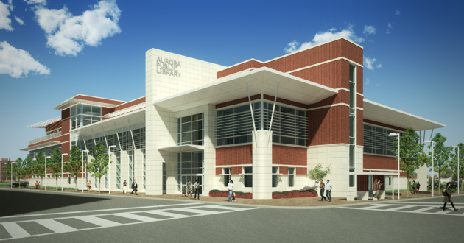 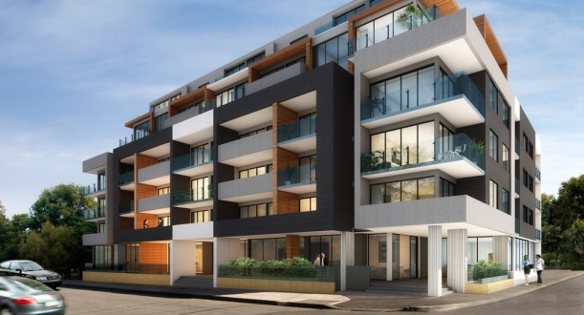  
*In the picture to the left, a cantilevered roof is extended to protect the glass curtainwall from sun and weather, and the Entrance is highlighted and protected from weather by a cantilevered portico.  
In the picture to the right, recessed ground floor entryways provide shelter from sun and weather, and a thickened façade allows for balconies but also protects glass walls from exposure.*

B. Buildings shall maintain traditional architectural proportions. This may include, for example, smaller columns placed closer together for more vertical applications or the supports/columns having additional mass for horizontal applications. For clean, contemporary architecture, buildings must respond to human-scaled elements and elements specific to their context and our local environment.

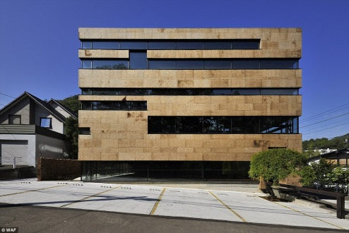 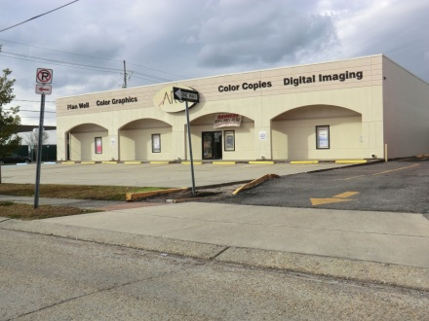  
*In the picture to the left, the building utilizes contemporary design but does not give prominence to its first floor and therefore appears top-heavy, and it does not highlight entryways nor provide protection from the elements.  
In the picture to the right, the building’s windows are not scaled properly to its overall size and window sizes are not suited to the building’s commercial use.*

C. Unless otherwise prohibited, pre-engineered industrial-style buildings devoid of scaling elements are allowed as long as they conform to all other standards and regulations.

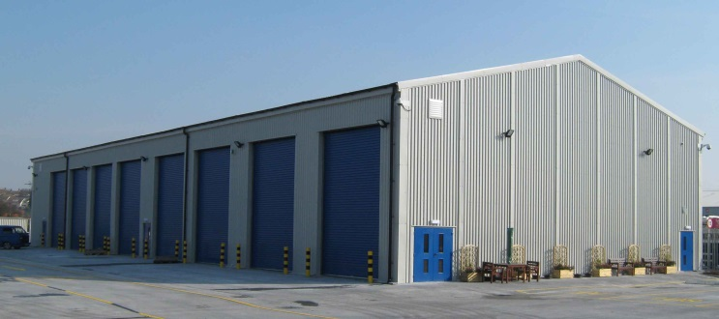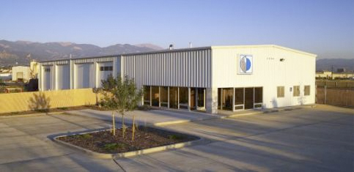  
*The picture to the left is an example of a pre-engineered industrial-style building devoid of scaling elements. The picture to the right is an example of the same style of building but with scaling elements.*

D. Multiple structures or buildings located on one property shall employ a consistent design vocabulary and use a unifying element such as material, color, or form.

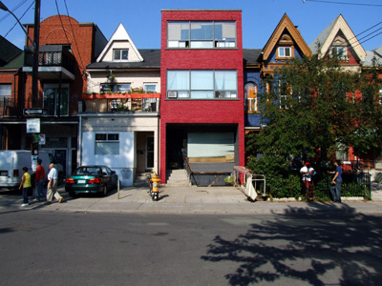 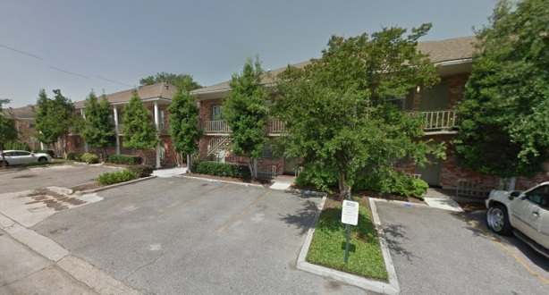  
*In the picture to the left the multi-tenant building uses multiple architectural styles that do not employ a consistent design vocabulary.  
In the picture to the right, several buildings on the same lot use consistent design elements including materials and architectural details.*

##### **Sec. 33-6.8.3.2. Façades.**

A. All façades of buildings visible from the street shall maintain the same standard of design as the front façade. This shall include the continued use of similar materials and architectural details.

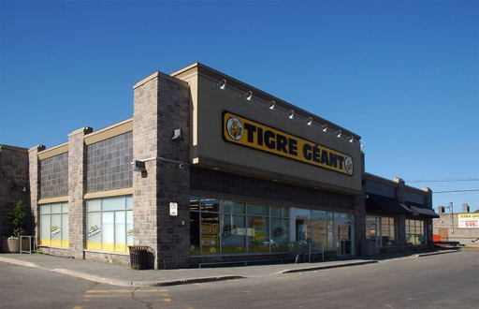  
*This picture shows an example of a building that uses the same standard of design on the side of the building, which is visible from the street, as on the front of the building.*

B. Horizontal planes shall be disrupted at least every twenty-five (25) feet of uninterrupted plane. The disruption may be accomplished by a change in plane, material, or opening, or a more significant design element such as a tower or gable, or other vertical elements.

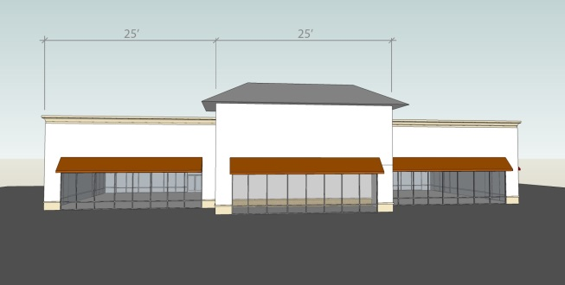  
*This diagram illustrates the disruption of horizontal planes at least every 25 feet through the use of a change in plane and the use of a tower.*

##### **Sec. 33-6.8.3.3. Entrances.**

Each principal building shall have a clearly defined, inviting, and highly visible entrance enhanced with distinguishing features, such as but not limited to canopies, galleries, porticos, or material or plane changes.

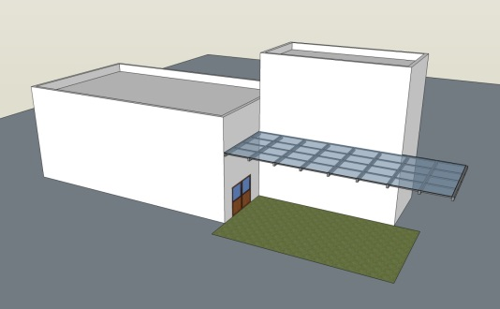  
*This diagram illustrates the use of a cantilevered roof to clearly define an inviting, highly visible building entrance.*

##### **Sec. 33-6.8.3.4. Openings.**

A. *Ground floor*. Table 33-6.8.3.4-1 provides the minimum percent of the street-facing building façade between the elevations of two (2) and ten (10) feet above the first finished floor that shall be comprised of transparent doors or windows that provide a view of the interior area within three (3) feet of the opening.

B. *Upper or above-ground floors*. Table 33-6.8.3.4-1 provides the minimum percent of the street-facing building façade above the ground floor that shall be comprised of windows, which:

1. May be constructed of spandrel; mirrored, frosted, or decorative glass; or glass block; and

2. Shall be:

a. Horizontally aligned with openings on adjacent buildings;

b. Vertically aligned; or

c. Proportionate with openings on the ground floor of the building.

C. Calculations for openings and transparency shall be independently computed for and applied to each street-facing building façade and shall not include building façades that are both visible from and perpendicular to a street (see Figure 33-6.8.3.4-1).

**Table 33-6.8.3.4-1. Minimum Percent Openings**

|  |  |  |
| --- | --- | --- |
|  | **Ground floor** | **Upper or above-ground floors** |
| **CPZ-Ped** | 70% | not applicable |
| **FC-1** | 70% | 30% |
| **FC-2** | 60% | 20% |
| **FC-3** | 30% | 30% |

**Figure 33-6.8.3.4-1: Street-Facing Building Façades**

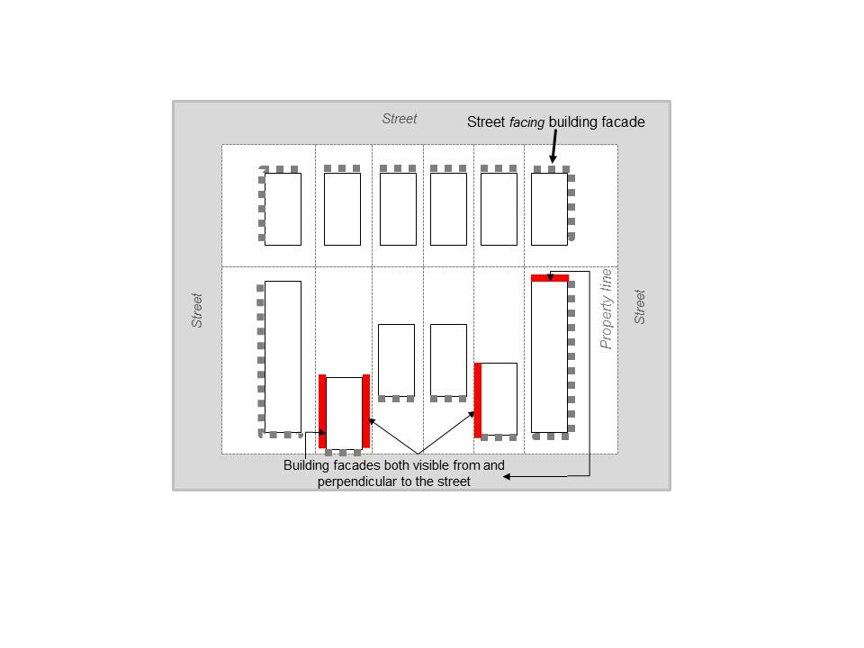

##### **Sec. 33-6.8.3.5. Roofs.**

Roofs shall have a slope not greater than 12:12 or less than 4:12. Flat roofs are allowed.

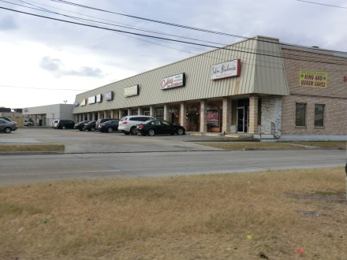 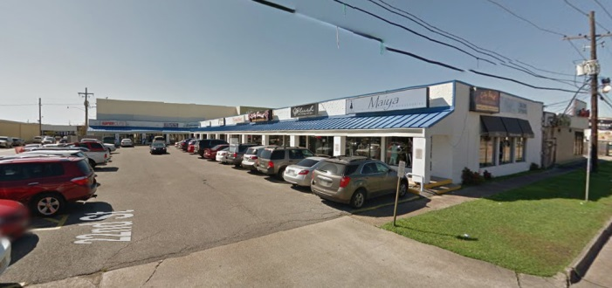  
*The picture to the left is an example of a roof slope that is not permitted because it is greater than 12:12. The picture to the right is an example of a roof slope that is permitted, because it is between 12:12 and 4:12.*

**Sec. 33-6.8.3.6. Canopies.**

A. Unless site conditions preclude, canopies shall be attached to and made an integral part of the main building.

B. If permitted, free-standing canopies, such as those used as porte-cocheres, shall be of similar style and materials as the building.

##### **Sec. 33-6.8.3.7. Materials.**

A. *Context and Alternatives.* Materials shall be reviewed for compliance with architectural context.

B. *Façade*.

1. At least eighty (80) percent of each building façade visible from the street, excluding window and door area, shall be clad in brick, stone, stucco, textured masonry, wood, or architectural pre-cast concrete. This requirement shall be independently computed for and applied to each applicable building façade.

2. Other alternative materials may be considered depending on overall architectural design.

3. Prohibited materials are plain concrete block, exposed aggregate (rough finish) concrete wall panels, exterior insulating finish systems (EIFS) or synthetic stucco, plastic, vinyl, and metal with exposed fasteners.

C. *Roof*. Wood shakes, slate/tile, rigid shingles with ridge tiles, asphalt shingles, and metal (corrugated, v-crimp, and standing seam) are allowed. Standard flat roof materials are also allowed.

D. *Changes in materials*. Changes in materials should have a clear line of demarcation, such as by offset, reveal, or border.

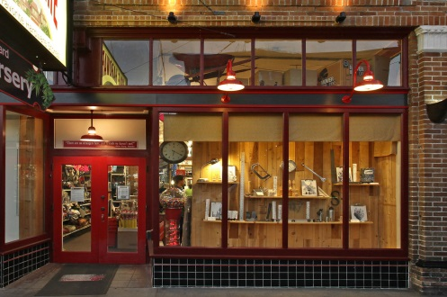  
*This picture shows an example of the use of borders   
and offset to denote a change in materials.*

#### Sec. 33-6.9. Site design.

##### **Sec. 33-6.9.1. Purpose (reserved).**

##### **Sec. 33-6.9.2. Residential sites (reserved).**

##### **Sec. 33-6.9.3. Multiple-Family, Commercial, Industrial, and Civic sites.**

This section, as a whole or by subsection, shall only apply to multiple-family, commercial, industrial, and/or civic developments where specifically required by a base or overlay zoning district.

##### **Sec. 33-6.9.3.1. Circulation.**

A. In commercial parking lots, internal pedestrian walkways shall be distinguished from driving surfaces through the use of color or special materials.

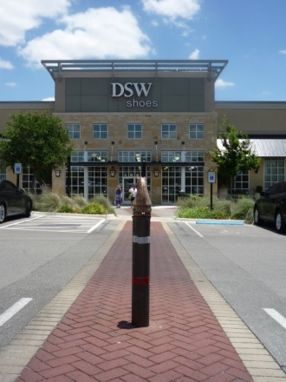  
*This picture shows an example of the use of color and a special pattern to distinguish a pedestrian walkway from a drive aisle in a parking lot.*

B. Sidewalks along commercial facades that feature a customer entrance must connect to parking areas.

##### **Sec. 33-6.9.3.2. Outdoor lighting.**

A. Outdoor illumination of any building, seating area, plaza, courtyard, landscaping, sign, or similar purpose shall not be aimed, directed, reflected, focused, or mounted to cause direct light from the luminaire to be directed toward residential uses, or to create up light, spill light, or glare perceptible to persons operating motor vehicles on public ways.

B. The installation of any mercury-vapor fixture or lamp is prohibited.

##### **Sec. 33-6.9.3.3. Fences and walls.**

See Sec. 40-743.5 Regulations for fences of this Code.

##### **Sec. 33-6.9.3.4. Mechanical and service equipment and areas.**

A. *Dumpsters*. Where permitted, dumpsters shall:

1. Be located behind the front or corner side building line;

2. Not be located on the same side of the development as residential development unless the Property buffer greenspace area in compliance with Sec. 33-6.25.4. Standards is provided; and

3. Be in accordance with Chapter 16 of this Code, including the hardship provision. In situations where the regulations of Chapter 16 and the regulations of this section are in conflict, the more restrictive shall apply.

B. Where possible, vending machines, ice machines, and restrooms shall be located inside the main building.

##### **Sec. 33-6.9.3.5. Outdoor speakers.**

A. No outdoor speaker shall be allowed within one hundred (100) feet measured in a straight line, without regard to intervening structures, from the speaker to the closest property line of a residential zoning district.

B. Any public address system located on site shall be oriented to minimize sound intrusion onto abutting properties.

C. All regulations of this Code regarding noise shall be met.

#### Sec. 33-6.10-24. Reserved.

**SECTION**  That Chapter 33 Unified Development Code, Article 6 General Development Standards, Division 4 Parking and Storage Standards, Sec. 33-6.35 Parking, loading, and clear vision, is hereby amended to rename the section and clarify the reference, to read as follows:

#### Sec. 33-6.35. Parking.

See Article XXXV Off-street Parking, Loading, and Clear Vision Area Regulations in Chapter 40 of this Code.

**SECTION**  That Chapter 33 Unified Development Code, Article 6 General Development Standards, Division 4 Parking and Storage Standards, Sec. 33-6.35 Parking, is hereby amended to add subsections for off-site parking, shared parking, on-street parking, and cooperative parking agreements, to read as follows:

#### Sec. 33-6.35.1. to 33-6.35.3. Reserved.

#### Sec. 33-6.35.4. Off-site parking.

A. *Generally*. Where permitted, required parking may be provided, in whole or in part, on an off-site parking facility in accordance with the requirements of this section.

B. *Districts where permitted*. Off-site parking spaces shall:

1. Be located within a district which would permit the use to which such parking is accessory; and

2. Not be permitted in the following zoning districts: S-1 Suburban, R-1D Rural Residential, R-1C Rural Residential, R-1B Suburban Residential, R-1A Single-Family Residential, R-1MH Manufactured Home, R-2 Two-Family Residential, RR-3 Three- and Four-Family Residential, R-3 Multiple-Family Residential, R-1TH Townhouses, or R-1CO Condominium.

C. *Proximity and access*.

1. Off-site parking facilities shall meet the requirements of Table 33-6.35.4-1. If required by Table 33-6.35.4-1, the following standards shall apply:

a. *Zoning*.

(1) For non-residential uses in residential districts, the zoning classification of the off-site parking shall be the same as or less restrictive than the zoning classification of the principal use.

(2) For other uses and districts, the off-site parking shall be located within a district which would permit the use to which such parking is accessory.

b. *Distance*. The maximum distance between the principal use and the off-site parking facility shall be measured along and following a reasonable and safe walking route from the nearest main entrance of the building or use to the off-site parking area.

c. *Right-of-way*.

(1) For non-residential uses in non-residential districts, the off-site parking shall not be separated from the principal use by a street, utility right-of-way, or public right-of-way.

(2) For other uses and districts, the off-site parking may be separated from the principal use by a public right-of-way, except roads classified on the Jefferson Parish Thoroughfare Plan as interstates, freeways, or major arterials.

d. *Frontage*. Frontage of the property to be used for off-site parking must face a street that also provides frontage to the property it serves.

e. *Access*. Access to the property to be used for off-site parking shall be provided only through non-residentially zoned property.

2. A continuous sidewalk or path system between the principal use and the off-site parking area shall be in place.

Table 33-6.35.4-1: Proximity and Access – Off-Site Parking

|  |  |  |  |  |  |
| --- | --- | --- | --- | --- | --- |
| **District/Use** | **Zoning** | **Distance (feet), maximum** | **Right-of-Way** | **Frontage** | **Access** |
| **Residential/ Non-residential** | ✓ | 300 | ✓ |  |  |
| **Non-residential/ Non-residential** | ✓ | 300 | ✓ | ✓ | ✓ |
| **Fat City/All** | ✓ | 600 | ✓ |  |  |

D. *Cooperative parking agreements*. Off-site parking utilized to meet the minimum parking requirements of this Code shall be subject to the provisions of Sec. 33-6.35.7. Cooperative parking agreements.

#### Sec. 33-6.35.5. Shared parking.

A. *Purpose*. Shared parking is based on the fact that certain uses operate at different times over a twenty-four-hour period with their greatest demand for parking occurring during mutually exclusive times. These uses are, therefore, able to share parking spaces during particular times and under certain conditions the total number of parking spaces otherwise required for individual uses may be reduced.

B. *Generally*. Where permitted, required parking may be satisfied, in whole or in part, with shared parking in accordance with the requirements of this section.

C. *Permitted uses and minimum development size*.

1. In the Fat City districts, any development may utilize shared parking.

2. In all other zoning districts, only developments that are in single ownership and include the following uses meeting the minimum thresholds may utilize shared parking:

a. Office uses totaling a minimum of three hundred thousand (300,000) square feet in gross floor area;

b. Hotel uses containing a minimum of two hundred fifty (250) guest rooms;

c. Retail uses totaling a minimum of fifty thousand (50,000) square feet in gross floor area;

d. Theaters, auditoriums, sports arenas, and places of public assembly containing a minimum of one thousand five hundred (1,500) seats; or

e. Restaurant and lounge uses totaling a minimum of four thousand five hundred (4,500) square feet in gross floor area.

D. *Shared parking calculation*. The application shall demonstrate that the number of parking spaces provided will satisfy the minimum parking requirement by one of the following methods:

1. Through peak use analysis approved by the Parish Traffic Engineer, using the latest peak demand analysis published by the Institute of Traffic Engineers (ITE) or other source acceptable to the Parish Traffic Engineer; or

2. Through application of Table 33-6.35.5-1 Shared Parking Calculations, using the following steps:

a. Determine the minimum parking requirement for each land use as if it were a separate use;

b. Multiply each minimum required parking by the corresponding percentages for each of the five (5) time periods set forth in Columns (B) through (F);

c. Calculate the total for each time period; and

d. Select the total with the highest value as the required minimum number of parking spaces.

**Table 33-6.35.5-1: Shared Parking Calculations**

|  | **Weekday** | | **Weekend** | |  |
| --- | --- | --- | --- | --- | --- |
| **(A) Land Use** | **(B)**  **Daytime**  **(6AM–6PM)** | **(C)**  **Evening**  **(6PM – midnight)** | **(D)**  **Daytime**  **(6AM – 6PM)** | **(E)**  **Evening**  **(6PM – midnight)** | **(F)**  **Nighttime**  **(midnight – 6AM)** |
| Office | 100% | 25% | 20% | 5% | 5% |
| Hotel | 85% | 100% | 85% | 100% | 75% |
| Retail | 75% | 90% | 100% | 80% | 5% |
| Entertainment/ commercial | 65% | 100% | 80% | 100% | 10% |
| Restaurants and Lounges | 90% | 100% | 100% | 100% | 10% |
| Residential | 70% | 100% | 80% | 100% | 100% |
| Industrial | 100% | 25% | 20% | 5% | 5% |
| All others | 100% | 100% | 100% | 100% | 100% |

D. *Reserved parking*. Reserved parking spaces may not be shared.

E. *Cooperative parking agreements*. Shared parking utilized to meet the minimum parking requirements of this Code shall be subject to the provisions of Sec. 33-6.35.7. Cooperative parking agreements.

F. *Variances*. No variances or exceptions to this section shall be granted by the Board of Zoning Adjustments.

#### Sec. 33-6.35.6. On-street parking.

A. *Generally*. Where on-street parking is permitted to be utilized to meet the minimum parking requirements of this Code, the provisions of this section shall apply.

B. To be eligible to count toward required parking, each on-street parking space shall:

1 Meet specifications established by the Department of Engineering for dedicated on-street parking; and

2. Have at least fifty (50) percent of its length or width along the curb line located between the extension of the side property lines of the property for which the on-street parking shall be counted.

#### Sec. 33-6.35.7. Cooperative parking agreements.

A. *Generally*. Where off-site or shared parking is utilized to meet the minimum parking requirements of this Code, the provisions of this section shall apply.

B. Cooperative parking agreement. A cooperative parking agreement shall include:

1. A written agreement between the owners and lessees of the properties affected, provided that the written agreement shall:

a. Be executed for a minimum of twenty (20) years;

b. Include a reference to the plans required by subsection 2 below;

b. Require review and approval by the parish attorney;

c. Be recorded;

2. Plans showing:

a. The location of the uses and parking facilities affected;

b. Notes describing the off-site or shared parking arrangement, including the schedule of times for shared parking;

c. A note referencing the written agreement required by subsection 1 above;

C. *Procedures*. To establish and maintain a cooperative parking agreement to satisfy required parking, the following requirements shall apply:

1. *Application requirements*. The following shall be submitted:

a. A stamped copy of the fully executed and recorded cooperative parking agreement in compliance with subsection B above;

b. An affidavit from each owner or lessee of the properties subject to the cooperative parking agreement testifying that the spaces are not encumbered by other uses or agreements and that the spaces will be retained pursuant to the agreement;

c. A cross access agreement where parking lots subject to the cooperative parking agreement abut;

d. Sufficient evidence to establish the status of applicants as owners of parties in interest.

2. *Application filing and approval*. If the cooperative parking agreement satisfies required parking that is:

a. Part of a development that requires a subdivision or site plan review by the Planning Department:

(1) The application shall be filed with and subject to the approval of the Planning Director;

(2) The cooperative parking agreement shall be noted on the affected subdivision or site plan;

(3) If an ordinance is required, the cooperative parking agreements shall be referenced in the ordinance.

b. Not part of a development that requires a subdivision or site plan review by the Planning Department, the application shall be filed with and subject to the approval of the Director of Inspection and Code Enforcement.

3. *Annual renewal*. An affidavit stating that the cooperative parking agreement is valid and no change in use or hours of operation of the affected properties has occurred shall be submitted annually to the Director of Inspection and Code Enforcement.

4. *Amendments or cancellations*. Pursuant to the same procedure and subject to the same limitations and requirements by which the cooperative parking agreement was approved and registered, any such plan may be amended or withdrawn, either partially or completely, if all land and structures remaining under such plan comply with all the conditions and limitations of the plan, and all land and structures withdrawn from such plan comply with the regulations of this Section.

D. *Records*. The Director of Inspection and Code Enforcement shall maintain all records of cooperative parking agreements.

E. *Violations*.

1. A violation shall occur in the following circumstances:

a. If a use is operated at a time other than during the hours of operation specified in the cooperative parking agreement.

b. If the cooperative parking agreement expires or otherwise terminates and results in a parking deficiency.

2. If any use is operated in violation of a cooperative parking agreement:

a. The Director of Inspection and Code Enforcement shall revoke the Certificate of Use or Occupancy.

b. Any and all approvals shall be subject to revocation.

c. Continuation or expansion of the use shall be prohibited unless the use is brought into compliance with the parking regulations of this Section.

**SECTION**  That Chapter 33 Unified Development Code, Article 6 General Development Standards, Division 4 Parking and Storage Standards, is hereby amended to add sections for loading and clear vision area, and renumber outdoor storage, to read as follows:

#### Sec. 33-6.36. Loading.

See Article XXXV Off-street Parking, Loading, and Clear Vision Area Regulations in Chapter 40 of this Code.

#### Sec. 33-6.37. Clear vision area.

See Article XXXV Off-street Parking, Loading, and Clear Vision Area Regulations in Chapter 40 of this Code.

#### Sec. 33-6.38. Outdoor storage (reserved).

**SECTION**  That Chapter 33 Unified Development Code, Sec. 33-10.2 Definitions applicable to this entire UDC, is hereby amended to add, amend, or delete certain definitions, to read as follows:

* * *

*Building* shall mean any structure designed or built for the support, enclosure, shelter or protection of persons, animals, chattels or property of any kind.

*Bulk plane* shall mean an imaginary inclined plane, rising over a lot, drawn at a specified angle, and used in conjunction with yard requirements, lot size requirements, and height limits as delineated in the district regulations, to establish the maximum bulk of a structure. This definition shall not be construed to mean that solid roofing to follow the angle of the plane is encouraged. Where bulk plane is required, upper floors are set back increasingly greater distances from the street or sides of the lot, often creating “wedding cake” style architecture. The bulk plane concept is illustrated in Figure 40.3.1:

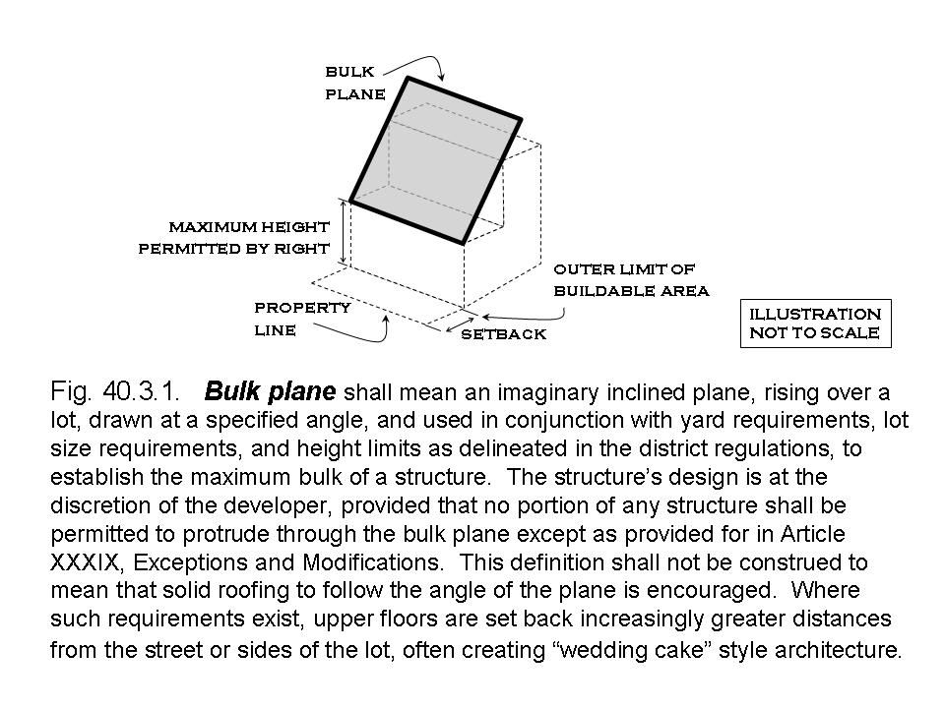

*Canal* shall mean any excavation below the surface of the earth having a width at its top of thirty-five (35) feet or more.

*Child care center* shall mean a licensed private facility, nursery school, pre-school or kindergarten that provides non-medical care to children under the age of eighteen (18), in need of professional services, educational services, or assistance for sustaining the activities of daily living or for the protection of the individual on a less than twenty-four-hour basis.

* * *

*Mixed-use building* shall mean a building containing both residential and nonresidential uses, where the residential or nonresidential use comprises at least ten (10) percent of the floor area. For the purpose of this definition, residential uses shall include all uses with an LBCS Function Code of 1100 or 1200.

*Motel* shall mean a building or group of buildings containing six (6) or more guest rooms where access to individual units is from exterior walkways or courts and which are used, rented, or hired for lodging or sleeping purposes by transient guests.

*Mural* shall mean a work of graphic art painted or applied to a building wall which does not contain advertising, commercial messages, or logos. A mural shall not be considered a sign.

*Non-residential Use or Business* shall mean an independent business requiring an occupational license that may be owned, operated and managed independently of other businesses within a building. Each business shall have separate access, though they may be connected by a common mall or hallway*.*

* * *

*Ornamental Fence* shall mean a decorative fence constructed of wrought or cast metal and other similar durable materials that the director of inspections and code enforcement or the planning director, as applicable, determines are substantially similar in appearance. Posts and supports shall not be greater than eighteen (18) inches in width, unless approved by the applicable director. This definition excludes barbed wire and chain link fences.

*Outdoor storage* shall mean the keeping, in an unenclosed or unroofed area of a commercial or industrial development, of any goods, material, or merchandise in the same place for more than twenty-four (24) hours.

*Parcel* shall mean a lot or tract of land described by plat, deed or other legal instrument that allows transfer of fee simple ownership without the addition or removal of property boundary lines.

* * *

*Parking lot* shall mean an open hard-surfaced area used for temporary parking of motor vehicles.

*Parking, shared* shall mean the use of the same off-street parking space to satisfy the minimum parking requirement for two (2) or more uses.

*Parking space* shall mean a hard-surfaced area permanently reserved for the storage of one (1) automobile, connected with a street or alley by a hard-surfaced driveway providing unobstructed ingress and egress for motor vehicles.

* * *

*Service vehicle* shall mean a car or truck that provides services for the business and shall not include vehicles used by employees to commute to and from work. Service vehicles shall exclude heavy equipment and any vehicle requiring a class A or class B driver’s license to operate.

*Story* shall mean the portion of a structure, other than a basement, included between the surface of any floor and the surface of the floor above or, if there is no floor above, then the space between such floor and the ceiling above. A basement used for dwelling purposes is considered a story.

* * *

*Streetscape* shall mean the general appearance of a block or group of blocks with respect to the structure, setbacks from public rights-of-way, open spaces, and the number and proportion of trees and other vegetation.

*Structure* shall mean anything constructed or erected, the use of which requires a location on the ground, or attached to something having a location on the ground, including but without the generality of the foregoing, advertising signs, billboards, back stops for tennis courts, fences and pergolas.

* * *

*Traffic Engineering Division Supervisor* shall mean the Jefferson Parish Traffic Engineering Supervisor or the supervisor’s designee.

*Transparent* shall mean that the door or window is constructed of non-reflective clear or lightly tinted glass and shall not include non-reflective opaque or darkly tinted glass.

*Truck stop* shall mean a structure(s) or land used primarily for the retail sale of fuel for trucks and incidental service or repair of trucks including but not limited to: attendance eating, and truck parking facilities, but not to include the storage of vehicles for the purpose of using parts of such vehicles for sale or repair. Such a facility may include video poker gaming, but only if such a facility is on a site of at least ten (10) acres and meets the criteria listed in Article XXX, Industrial District M-1.

* * *

**SECTION**  That Chapter 33 Unified Development Code, Sec. 33-10.3.1 Reserved, is hereby amended to add definitions specific to Fat City, to read as follows:

Sec. 33-10.3.1. Fat City.

*Clubs* shall mean buildings and facilities owned and operated by a corporation, association, person, or persons for social, educational or recreational purpose, but not for profit, or not to render a service that is normally carried on as a business or that excludes minors.

*Streetscape zone* shall mean the area that extends between the back of curb or curb zone and the front, or side in the case of a corner lot, building façade or build to line, and is composed of the frontage zone, furniture zone, and pedestrian zone as defined below and illustrated in Figure 33-10.3.1-1:

A. *Frontage zone* shall mean an area located between the pedestrian zone and the front, or side in the case of a corner lot, building façade or build to line, designated for entering and exiting buildings without creating conflicts with other pedestrian traffic.

B. *Furniture zone* shall mean an area located between the pedestrian zone and the back of curb designated for street furniture; lighting; appropriate landscaping; box planters; regulatory, warning, or guide signs; pedestal, controller box, or similar traffic control devices; and/or, the columns or posts that support awnings, canopies, balconies, or building overhangs.

C. *Pedestrian zone* shall mean an area located between the furniture zone and the frontage zone designated for pedestrian circulation and able to accommodate a wheelchair and walking companion side by side.

Figure 33-10.3.1-1: Streetscape Zone.

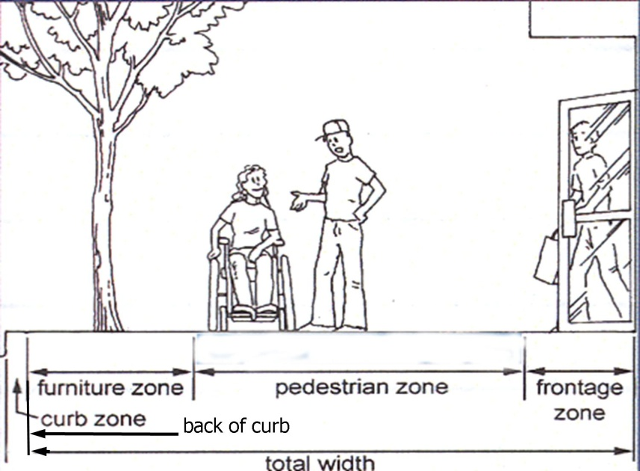

**SECTION**  That Chapter 40 Zoning, Sec. 40-3 Definitions, is hereby amended to add, amend, or delete certain definitions, to read as follows:

* * *

*Mixed-use building* shall mean a building ~~that~~ containing~~s at least one floor with allowed~~ both residential and nonresidential uses, where the ~~and at least one floor with allowed~~ residential or nonresidential use~~s~~ comprises at least ten (10) percent of the floor area. For the purpose of this definition, residential uses shall include all uses with an LBCS Function Code of 1100 or 1200, as defined in Sec. 33-3.4 of this Code.

* * *

*Parking lot* shall mean an open hard-surfaced area used for temporary parking of motor vehicles.

*Parking, shared* shall mean the use of the same off-street parking space to satisfy the minimum parking requirement for two (2) or more uses.

*Parking space* shall mean a hard-surfaced area permanently reserved for the storage of one (1) automobile connected with a street or alley by a hard-surfaced driveway providing unobstructed ingress and egress for motor vehicles.

* * *

*Sign* definitions:

* * *

(3) *Attached sign* shall mean an on-premise sign attached to or painted on a building. A sign attached to the wall of an accessory building shall not be considered an attached sign.

(4) *Awning sign* shall mean a sign attached to or painted on the surface of an awning or canopy, generally parallel to the face of the building.

(5) *Detached sign* shall mean an on-premise sign not attached to or painted on a building but which is affixed to the ground. A sign attached to a flat surface such as a fence or wall of an accessory building shall be considered a detached sign.

* * *

(11) *Flat sign* shall mean any sign attached to, and erected parallel to the face of, or erected or painted on the outside wall of a building and supported throughout its length by such wall or building and not extending more than eighteen (18) inches from the building wall. Flat signs shall include marquee signs for the calculation of sign area, but shall not include canopy signs.

(12) *Hanging sign* shall mean a sign hanging from the underside of an awning, canopy, balcony, or similar building appendage located above a pedestrian walkway, but not from a marquee.

(13) *Illuminated sign* shall mean any sign designed to give forth artificial light or designed to reflect from one (1) or more sources of artificial light erected for the purpose of providing light for the sign.

* * *

(15) *Marquee sign* shall mean any sign attached to or hung from a marquee. For the purpose of this section, a marquee is a covered structure projecting from and supported by the building with independent roof and drainage provisions and which is erected over a doorway or doorways as protection against the weather.

(16) *Monument sign* shall mean a detached sign with the entire length in contact with the ground or a pedestal that rests upon the ground.

(17) *Off-premise sign* shall mean a sign advertising a use, facility, service, or product that is not located, sold, or manufactured on the same premises as the sign.

* * *

(20) *Projecting sign* shall mean a sign which is attached to and projects more than eighteen (18) inches from the face of a wall or building, but not projecting above the parapet or eave line of the building.

(21) *Projector sign* shall mean a sign using a projector to display content on a screen or faҫade of a building.

(22) *Roof sign* shall mean a sign above the roof of a building which is fastened to and supported by the roof of a building or an attached sign which extends above the roof line or parapet wall of a building.

* * *

(25) *Travelling* shall mean a mode of message transition on an EVM sign where the message appears to move horizontally across the sign panel.

(26) *Window sign* shall mean a sign etched into, applied to, or hung within four (4) feet of the inside pane of a window.

* * *

**SECTION**  That Chapter 40 Zoning, Sec. 40-661 General requirements (Off-street parking), subsection (a), is hereby amended to remove provisions for off-site parking and clarify provisions for residential uses, to read as follows:

(a) Location of required parking spaces except as may otherwise be provided in this Section, shall be located as provided below. For the purpose of this subsection (a), one-family, two-family, three-family, four-family dwellings, condominiums, and townhouses shall be considered residential uses, and the following zoning districts shall be considered non-residential districts: GO-2 General Office District, GO-1 General Office District, H-1 Medical Service District, H-2 Medical Service District, BC-1 Business Core District, C-1 Neighborhood Commercial District, BC-2 Business Core District, C-2 General Commercial District, OW-1 Office Warehouse District, M-1 Industrial District, M-2 Industrial District, M-3 Industrial District, U-1R Unrestricted Rural District, U-1S Unrestricted Suburban District, P-1 Penal and Criminal Correctional Institution District, MUCD Mixed Use Corridor District, and GED Gaming District.

(1) *Residential uses in all districts*. Required parking spaces for residential uses in all zoning districts shall:

a. Be located on the same lot as the principal use;

b. Not be located in the required front yard area, except as provided in (j) below; and

c. In cases where the residential use fronts a street with a right-of-way less than fifty (50) feet in width, be located no less than forty-five (45) feet from the centerline of the street, except as provided in (j) below.

(2) *Permitted non-residential uses in residential districts*. Required parking spaces for non-residential uses permitted and located in residential zoning districts shall:

a. Not be located in the required front yard;

b. Conform to the parking requirements provided for in the appropriate residential zoning district; and

c. Be located on the same lot as the principal use, or may be located off-site in accordance with Sec. 33-6.35.4 Off-site parking of this Code.

(3) *Non-residential uses in non-residential districts*. Required parking spaces for non-residential uses in non-residential zoning districts shall be located on the same lot as the principal use, or may be located off-site in accordance with Sec.33-6.35.4 Off-site parking of this Code.

**SECTION**  That Chapter 40 Zoning, Sec. 40-662 Off-street parking requirements (Off-street parking), is hereby amended to clarify provisions for parking for outdoor areas and for access to containers, to read as follows:

* * *

(f) When parking spaces are computed on the basis of the number of employees or other uses of the structure, building or use, the maximum number present at any one time shall govern.

(g) The calculation of required parking spaces shall not differentiate between indoor areas and outdoor areas occupied by the use.

(h) When computation of the number of required parking spaces results in a fraction of space, expressed as a fraction or decimal, one-half (1/2) and over shall require one parking space.

(i) Off-street parking spaces shall only be used for off-street parking in connection with the principal use and limited to the parking of passenger vehicles, trucks, and vans and not for storage of or access to containers or trailers except as provided in Sec. 40-750.

* * *

**SECTION**  That Chapter 40 Zoning, Sec. 40-664 Shared parking requirements for mixed-use developments (Off-street parking), is hereby amended to rename the section and replace the contents with a reference to Sec. 33-6.35.5 Shared parking, to read as follows:

Sec. 40-664. Shared parking.

See Sec. 33-6.35.5 Shared parking of this Code.

**SECTION**  That Chapter 40 Zoning, Sec. 40-683 On-premise sign regulations, subsection (e) Signs with supplemental criteria, is hereby amended to add supplemental criteria for projecting or hanging signs, to read as follows:

* * *

(5) *Projecting or Hanging Signs*. Any projecting or hanging sign shall be located at least eight (8) feet above ground level measured from the bottom of the sign to the top of the sidewalk, exterior walkway, or other surface.

**SECTION**  That the Municipal Code Corporation is hereby authorized and directed to correct any cross-references within the code that are affected by the renumbering of sections or subparagraphs via this ordinance.

This ordinance having been submitted to a vote, the vote thereon was as follows:

**YEAS: 6 NAYS: None ABSENT: (1) Templet**

This ordinance was declared to be adopted on the 23rd day of August, 2017, and shall become effective as follows, if signed forthwith by the Parish President, ten (10) days after adoption; thereafter, upon the signature by the Parish President, or, if not signed by the Parish President, upon expiration of the time for ordinances to be considered finally adopted without the signature of the Parish President, as provided in Section 2.07 of the Charter. If vetoed by the Parish President and subsequently approved by the Council, this ordinance shall become effective on the day of such approval.

